**The Winds of Boriken**

Senior Project  
System Manual

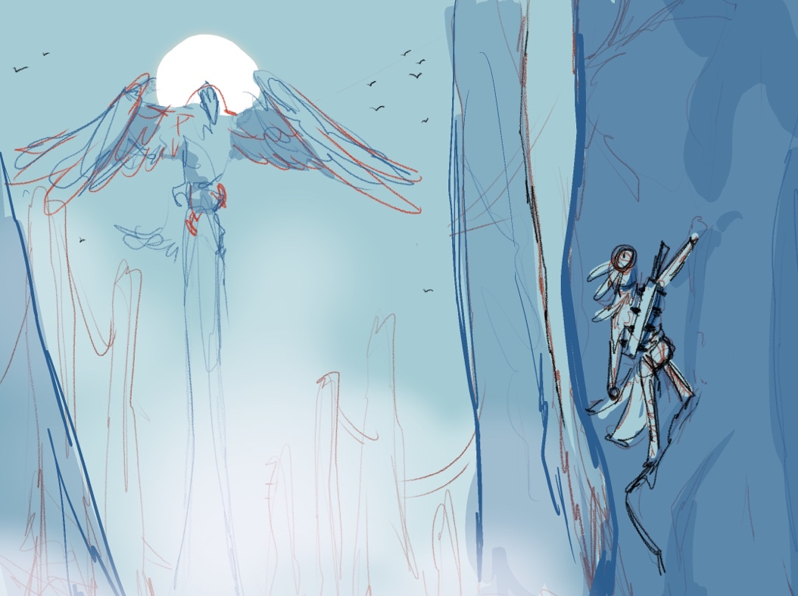

Paul Smith

psmith19@mail.stmarytx.edu

Spring 2022

Contents

Overview 1

Analysis and Requirements 6

Design 9

Installation 24

Sample Sessions 27

Troubleshooting 30

References 32

Source Code File Listings 1

Overview

*The Winds of Boriken* is a 2D side scrolling beat ‘em up game whose story and world take inspiration from the mythology of the indigenous people of the Caribbean, the Taíno. The game follows the story of Anahey, a young Borikeño girl who must travel to Oubao’bibitihura, the fabled Island of the Four Winds, to fulfill the ritual to become Kasike (Chief). Her quest is to enter the domains of the Guardians, divine birds that protect the Four Winds, and pluck a single feather from each. The game features four levels, with combat encounters with various enemy types and a boss fight. The game was developed using the Unity game engine.

**Problem/Issue**

The struggle of the main character throughout the game alludes to the struggle of the modern people of Puerto Rico. While this may not be overtly stated in the game, we hope that players will find the world interesting enough to research more about Puerto Rico and the Taino. Also, as avid fans of fantasy and video games ourselves, we wanted to create a game that featured characters of Latin heritage, as few games, especially those in the fantasy genre, contain Latino characters or stories.

**Motivation**

Fantasy is one of the most popular entertainment genres, yet most Western fantasy is inspired by Tolkien or European mythology, leaving the rich cultural heritage of the Latin people underrepresented, particularly in video games. Games like *God of War*, *The Elder Scrolls V: Skyrim*, and *The Witcher*, all take inspiration from European mythology, resulting in few people of color, much less Latin people of color, featured in their stories. When The Witcher was adapted into a Netflix series, many gamers were outraged when a prominent character in the games, a White red-headed sorceress, was played by a woman with darker skin and hair. More recently, I saw comments that Marvel was “pandering” after introducing a new superhero to the Marvel Cinematic Universe played by an Egyptian/Palestinian woman. This only further underscores the need for more diverse fantasy characters and worlds that explore the rich and underrepresented mythologies of cultures long absent from popular media. Beat ‘em up games in particular rarely portray Latin characters, and the women in those games are often reduced to narrative MacGuffins or portrayed in a fashion that a teenage boy would fantasize about.

**Background**

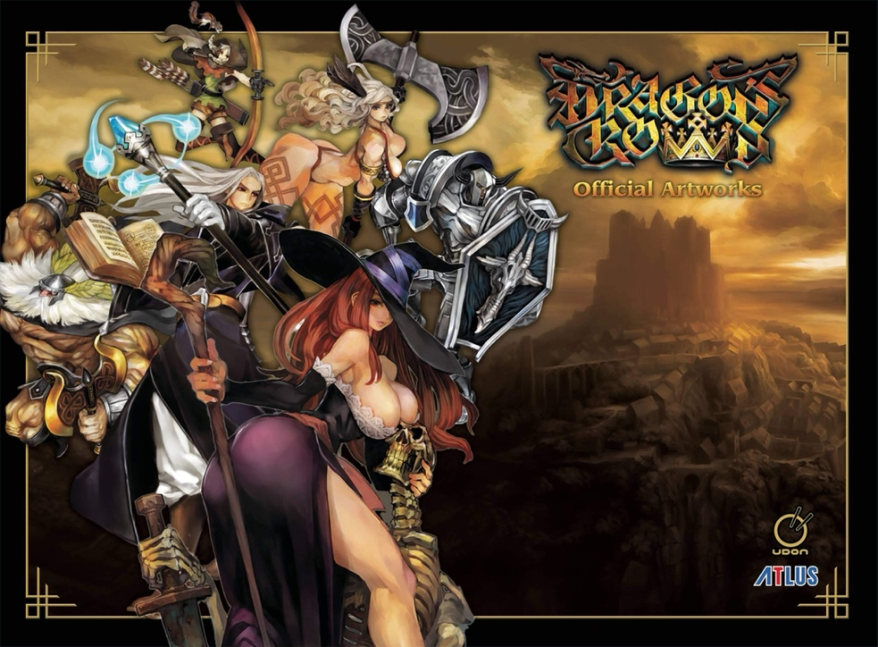According to thegamer.com in 20191, *Dragon’s Crown* is the best modern beat ‘em up game. Here is an image featuring the artwork of the main characters:

Image from: <https://www.amazon.com/Dragons-Crown-Official-Artworks-Vanillaware/dp/1772941115>

The women characters are overly sexualized and scantily clad, while the men are giant warriors. While this male power fantasy is not so overt in most games, gaming is currently a male dominated industry whose target demographic is more often than not young men. One of the biggest video game companies, Activision Blizzard, is currently being sued by the state of California for the pervasive harassment of its female employees and women at industry events, which can’t help but draw into question who the games they make are for. While I don’t propose that this project fix such widespread and serious issues, we can at least contribute a game designed for a diverse audience and be a part of the shift in attitude that video games are only for young men.

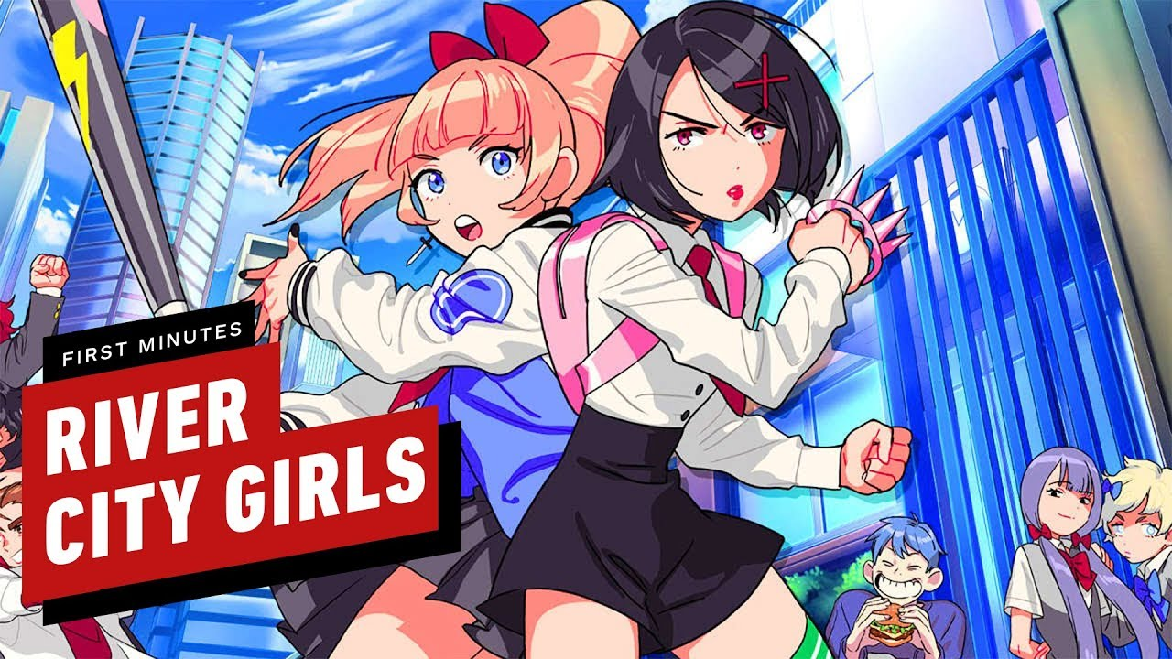Three games that many consider to be the most iconic of this genre, *Double Dragon*, *Final Fight*, and *River City Ransom*, all feature central narratives about rescuing the girlfriend of the main character. A recent 2019 release, *River City Girls*, a spiritual successor to *River City Ransom*, flips the script and makes the two main characters women who must rescue their boyfriends. While playing as Japanese school girls still feels like a game targeted at young men, even if the character models aren’t as gratuitous as other games, I think the developers of

Image from: <https://www.youtube.com/watch?v=FRYd3i3u6yI>

the game were clearly trying to go against the typical trend of male dominated beat ‘em ups.

The only beat ‘em up game I’ve played that features Latino characters is *99Vidas*, a game designed by a Brazilian development studio. The game is lighthearted and fun, and though all the main characters are men, there are playable women with designs appropriate for all ages. However, the narrative and world of this game are more focused on nostalgic references to the arcades of the 90s rather than the Latin culture in which the game was made.

Image from: <https://www.nintendo.com/games/detail/99vidas-definitive-edition-switch/>

Speaking about real world inspiration, the second goal of *The Winds of Boriken* is to encourage player’s interest in the history of the Taíno people, specifically those native to Puerto Rico. While the game itself is not intended to be outright educational, we hope to invest players enough that they would want to learn more, not unlike a Hollywood biopic leading to a Wikipedia deep dive. With this project, the background factual information will be provided directly through my web development project, a website that provides some background about the stories and myths that influenced the world and characters of the game. However, the website is not currently hosted.

**Solution**

I worked with a Puerto Rican artist to create the assets and help contribute an authentic Latin narrative to the fantasy and beat ‘em up genres. Since the Taíno people and their beliefs are little known by most people, the goal is to create a game that is exciting enough to encourage players to want to learn more about its real-world inspiration. Another goal for the game is to prominently feature women as strong characters, because we think there should be more women in stories who are cool in the same way male action heroes have been portrayed for decades.

**Benefits**

While I think all gamers could benefit from a Western fantasy story that takes inspiration from something other than Tolkien or European mythology, I think it would especially benefit young Latin gamers to see that fantasy can be more than elves and Greek gods; that there is a wealth of diverse fantastical stories that deserve the same attention given their European counterparts. The game is planned to be accessible to all audiences, so the game could potentially even be used to generate interest in Puerto Rican history in a classroom setting, though it would need to be paired alongside a curriculum that is uncommon in many schools. Also, through local multiplayer, families and friends can share the story of the game together and create an opportunity for discussion.

Analysis and Requirements

The following details the analysis behind the requirements that the development of the game sought to fulfill.

**Analysis**

The fundamental features of the game are derived from popular games in the beat em up genre, such as *Mother Russia Bleeds* and *Streets of Rage 4*. The player should have the ability to move in four directions in a 2D side scrolling environment. There should be a variety of enemy types that players must defeat in waves before progressing further through a level. These enemies tend to only have a single attack, and randomly decide between attacking, moving towards the player, waiting, or roaming in a random direction. Each level usually ends with a boss, who’s primary difference is the use of multiple attack patterns that deal more damage, and a larger health bar. The primary way of defeating enemies is by getting close enough to punch or grab them. Levels also typically have breakable containers that house pickups that increase either the player’s score or health. Because these games originated in arcades, most have lives’ systems so players would have to add quarters for more when they ran out. Most beat ‘em ups can be played with at least two players in local coop.

With this in mind, *The Winds of Boriken* has multiple levels, with objects designed for halting player progress until waves of enemies are defeated. Functionality for boss encounters was also developed, though there is currently only one at the end of the first level. The player is also able to trigger dialogue with friendly NPCs, so exposition can be delivered mid-level instead of through cutscenes. The entire game is playable cooperatively through local two player on the same keyboard.

**Requirements**

Because the assets of the game are not graphically or computationally expensive, the requirements are the same as those of the Unity engine, which can be found at <https://docs.unity3d.com/Manual/system-requirements.html>.

**Hardware and Software for a User**

While not currently available for play on the web, the intended platform for the game is WebGL, and should be playable on devices with keyboards that meet the official requirements from Unity, detailed below.

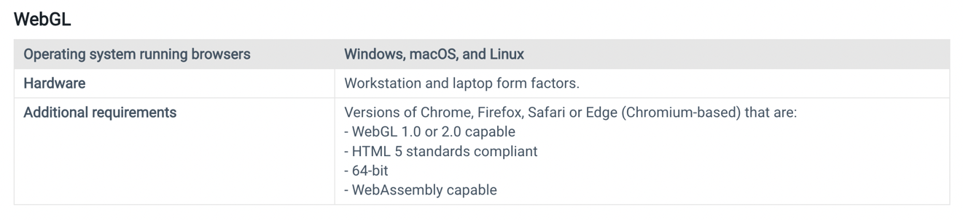

Desktop builds should also be playable on devices with keyboards that meet the below requirements.

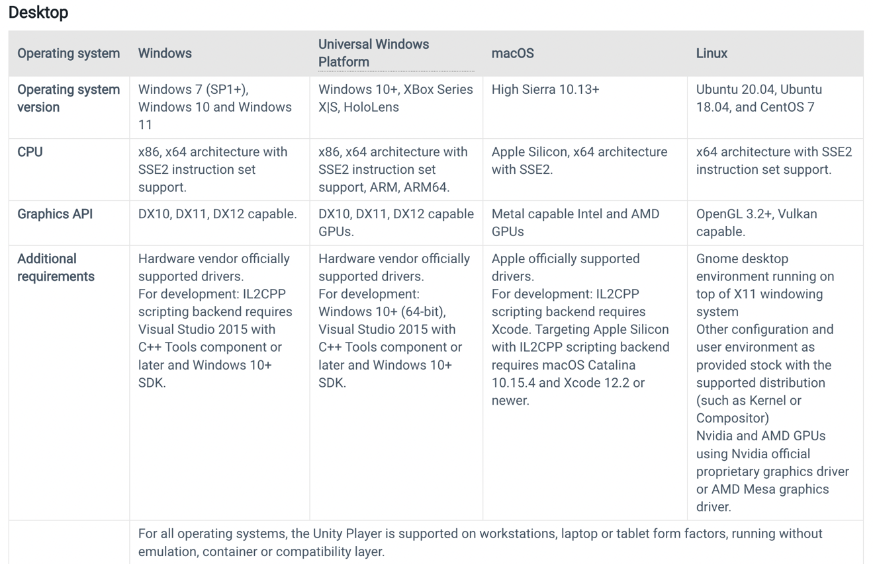

**Hardware and Software for a Developer**

Detailed below are the system requirements for running the Unity editor. The version used for the development of *The Winds of Boriken* is 2020.3.8f1 LTS. Later versions should work as well, though previous versions may not.

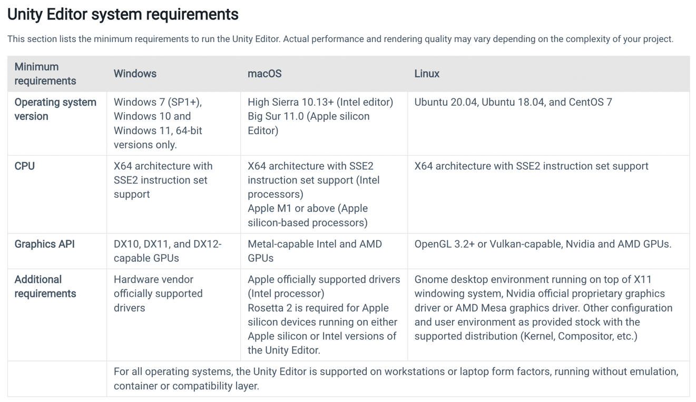

**Functionalities**

This section details all the actions that a player is able to perform in the game. The only type of user is a player, there are no admin or developer privileges built into the product. The gameplay mechanics and available player actions are the same throughout each level.

The player-controlled character can:

* Move in x and y directions
* Jump
* Jump attack
* Combo attacks when not jumping
* Change direction while attacking
* Grab
* Grab attack
* Pickup health and score items
* Die and respawn
* Dialogue with friendly NPCs
* Spawn a second player to play cooperatively on the same keyboard

Design

The design of the game is in the vein of classic beat ‘em up games like *Streets of Rage* and *Double Dragon*, featuring a scrolling 2D environment that will sometimes lock when enemies spawn and unlock when they are defeated. Not all enemies are spawned within battle events.

**Environments**

The primary development tool is the Unity game engine, with all scripting done in C# in Visual Studio. Unity was chosen because it is a free game engine popular among indie developers for its versatility, especially for 2D games. C# using Visual Studio is the default interface to the Unity scripting API.

**Data Structures**

Like most games, *The Winds of Boriken* is mostly made up of objects interacting with one another. The below class diagram details one of the most important interactions, that between the player controlled character and the enemies spawned when BattleEvents are triggered.

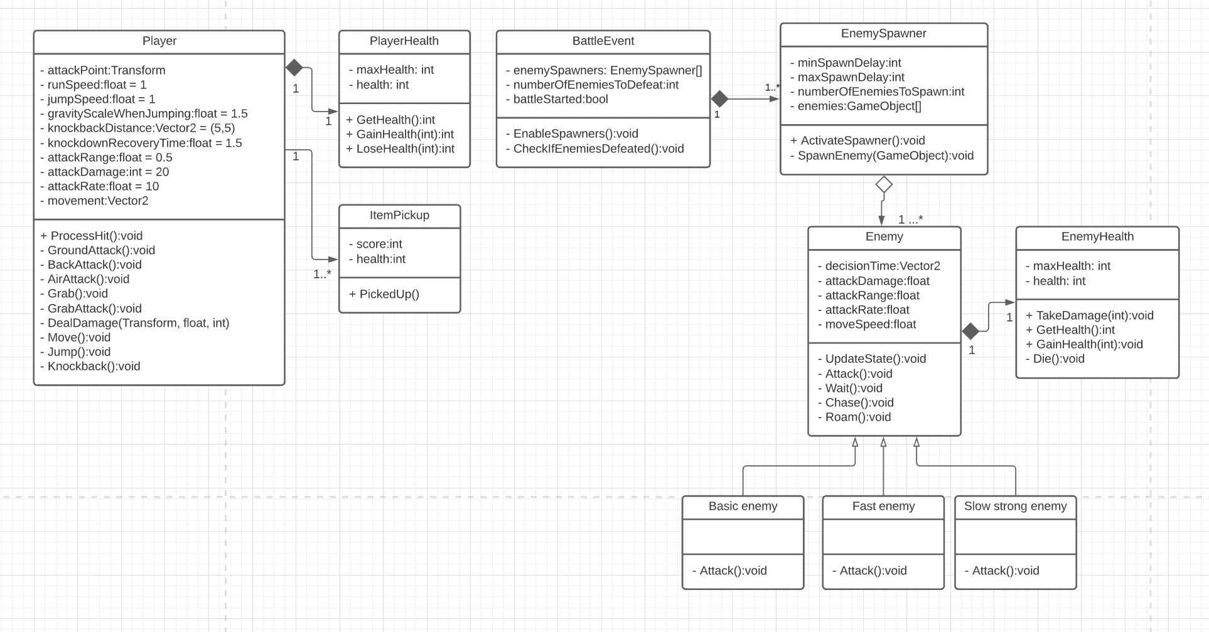

**Software Modules**

The game is not made up of large software modules, but rather many objects that interact with one another. The objects fundamental to the core gameplay loop are seen in the class diagram above, but there are many more objects that make sure the game functions properly behind the scenes. I grouped these together as managers, and they control various parts of the game, such as music, audio, multiplayer, game state, level loading, camera targeting, and dialogue.

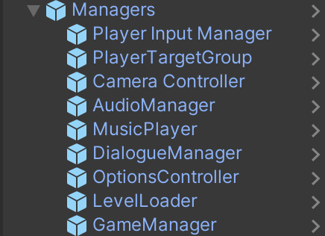

**System Structure**

The game is made up of four levels, though only the first is fully populated with enemy waves and a final boss fight. The subsequent levels have various enemies spread out across the environment, though all the tools for creating enemy encounters have been prefabbed so they can be simply clicked and dragged into the scene within the editor. The overall flow of the game can be seen in the chart below.

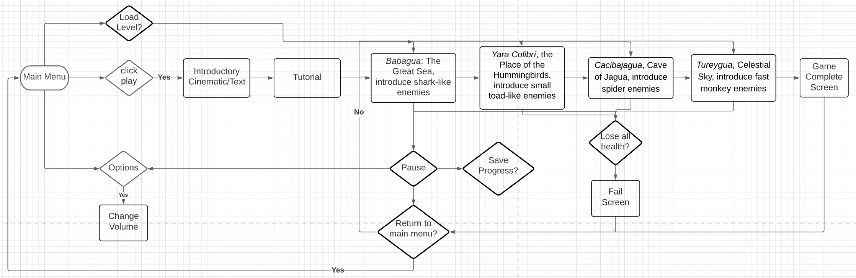

**Interfaces**

The following section shows all the major functionalities and screens of the game. Not every level is shown here, as the functionalities are the same for each, including the tutorial. The only difference in the tutorial is that enemy AI is turned off so that they cannot fight back. Screens with storyboards are bolded in the actions.

**Main Menu**

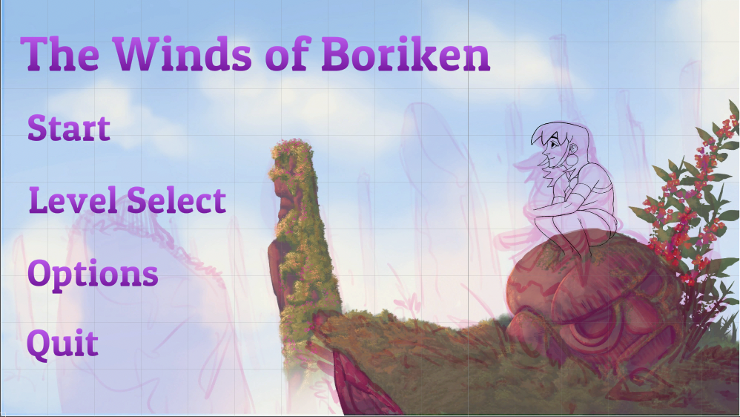

This is the starting screen of the game. All menu screens are controlled using the mouse.

The player can

* Select ‘Start’

Load tutorial scene

* Select ‘Level Select’

Go to **Level Select** screen.

* Select ‘Options’

Go to **Options** screen

* Select ‘Quit’

Quit the application if playing a desktop build. Otherwise just logs to the console that the user quit the game.

**Level Select**

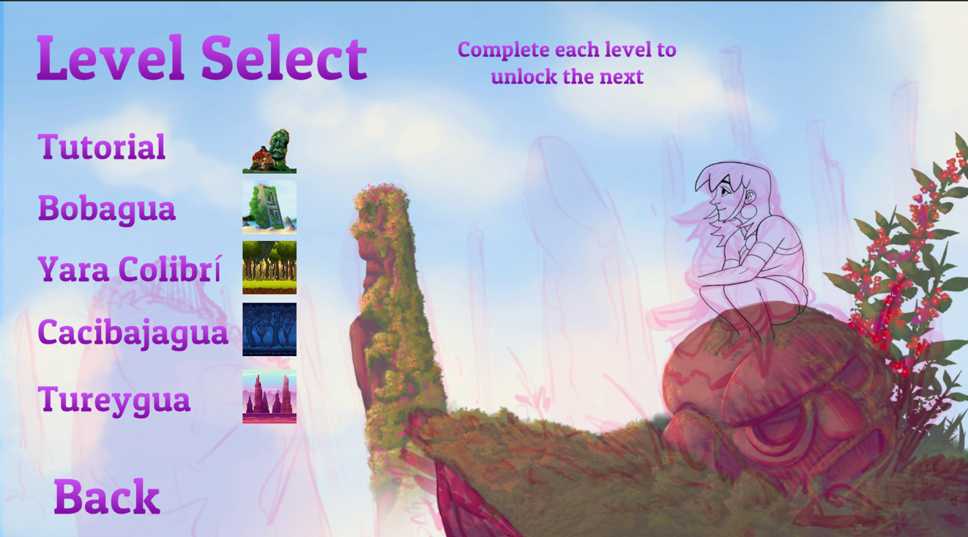

The player can load specific levels from this screen. Currently all levels are unlocked for development, but functionality was created for unlocking levels as they are completed. When this feature is enabled, levels that have not been unlocked are greyed out.

The player can

* Select ‘Tutorial’

Load tutorial scene

* Select ‘Bobagua’

Load Bobagua scene

* Select ‘Yara Colibri’

Load Yara Colibri scene

* Select ‘Cacibajagua’

Load Cacibajagua scene

* Select ‘Tureygua’

Load Tureygua scene

* Select ‘Back’

Go back to **Main Menu** screen

**Options**

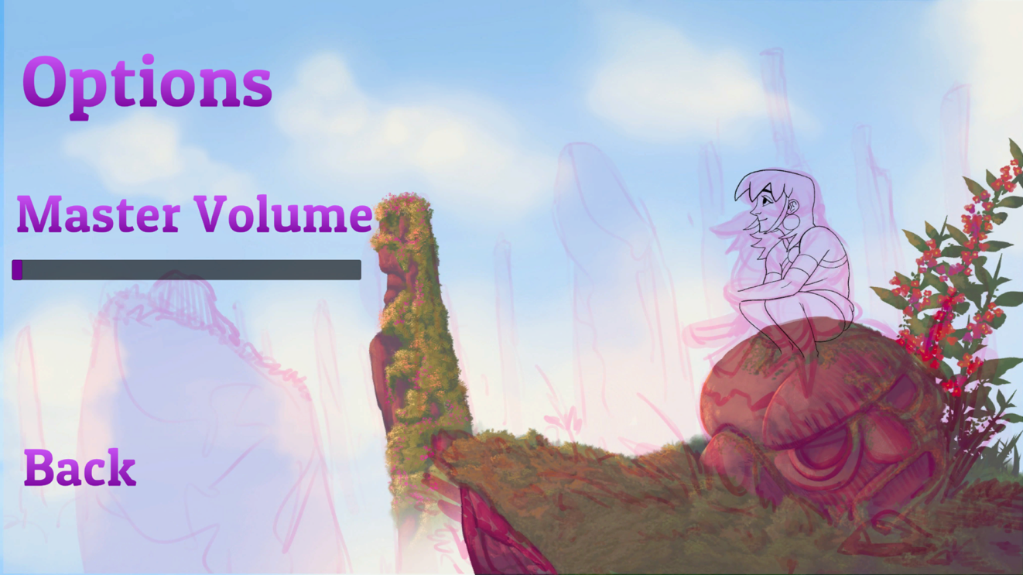

Currently the only option to the player is to control the master volume of all sounds and music in the game, though the player prefs controller could be expanded to manage any settings.

The player can

* Click slider

Drag slider to desired volume setting. Slider changes the value of the master volume with a min of 0 and max of 1

* Select ‘Back’

Go back to **Main Menu** screen

**Gameplay**

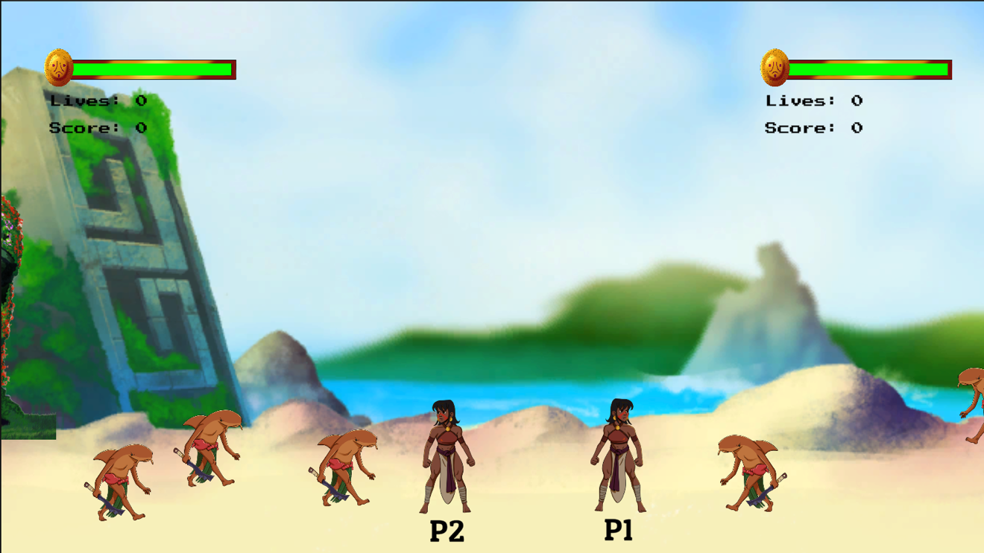

This is the primary screen of the game, where users move throughout the environment and defeat enemies as they come. The controls listed below are for single player/player one. The controls for the second player can be seen on the **Pause – Controls** screen.

The player can

* Press ‘W’

Move the player character up

* Press ‘A’

Move the player character left

* Press ‘S’

Move the player character down

* Press ‘D’

Move the player character right

* Press ‘space’

Jump

* Press “left system”

(This is the ‘command’ key on macs, the corresponding key on Windows machines should be “left ctrl’, though the game has only been tested on a Macbook.)

Basic attack.

Jump attack if done while jumping.

Grab attack if done while grabbing an enemy.

* Press “left shift”

Grab enemy if close enough and enemy is grabbable.

Throw enemy if grabbed

* Press “E”

Pickup item if next to one

Replay dialogue if next to an NPC with dialogue.

* Press “esc”

Freeze the gameplay and go to **Pause** screen.

**Gameplay – Player out of lives in multiplayer**

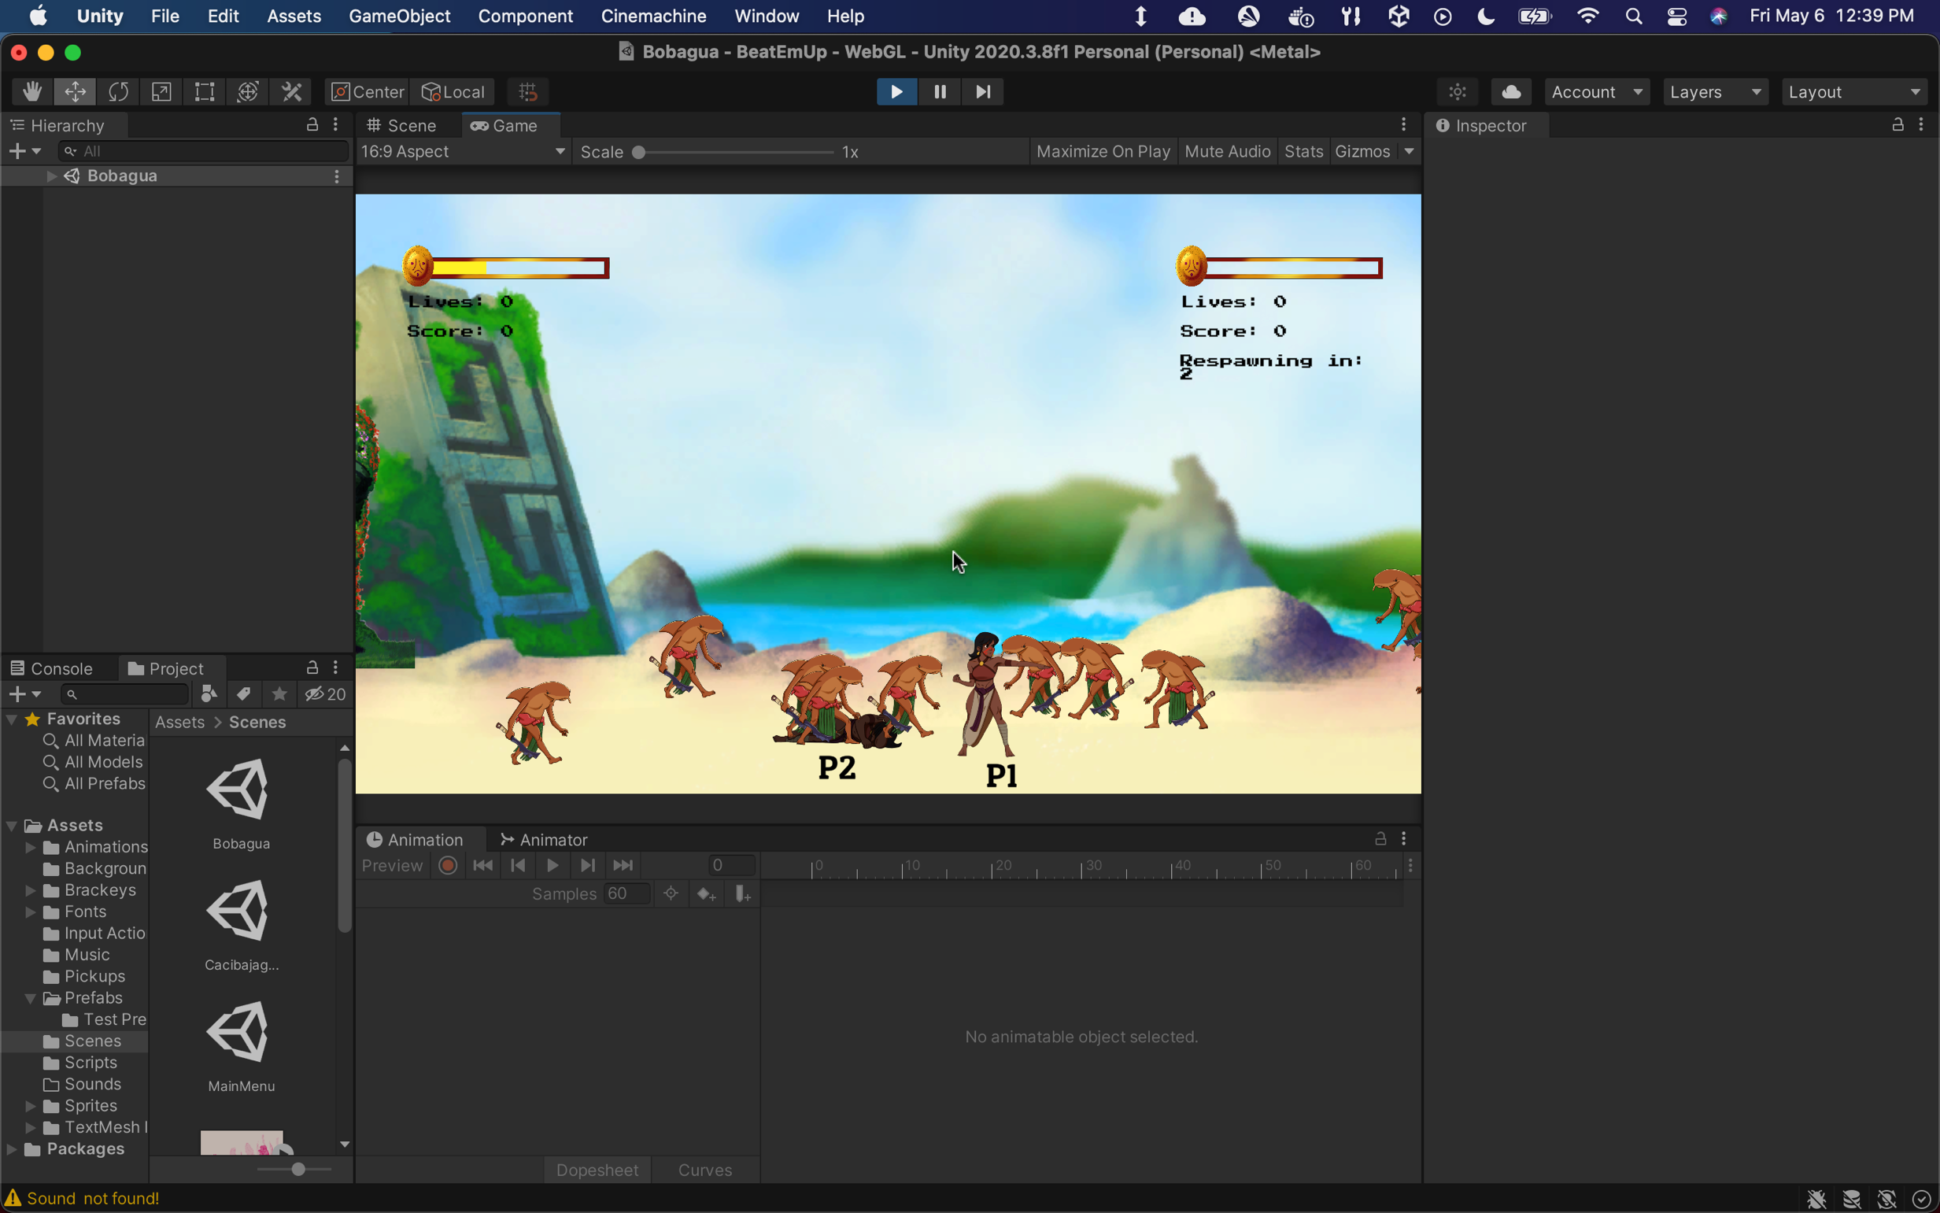

The actions that the user can take on this screen depend on the player. This screen only occurs in multiplayer when one of the player dies while the other is alive. The dead player must wait for the respawn timer to reach zero for there character to respawn, then they can continue playing and taking all the actions listed in **Gameplay.**

**Pause**

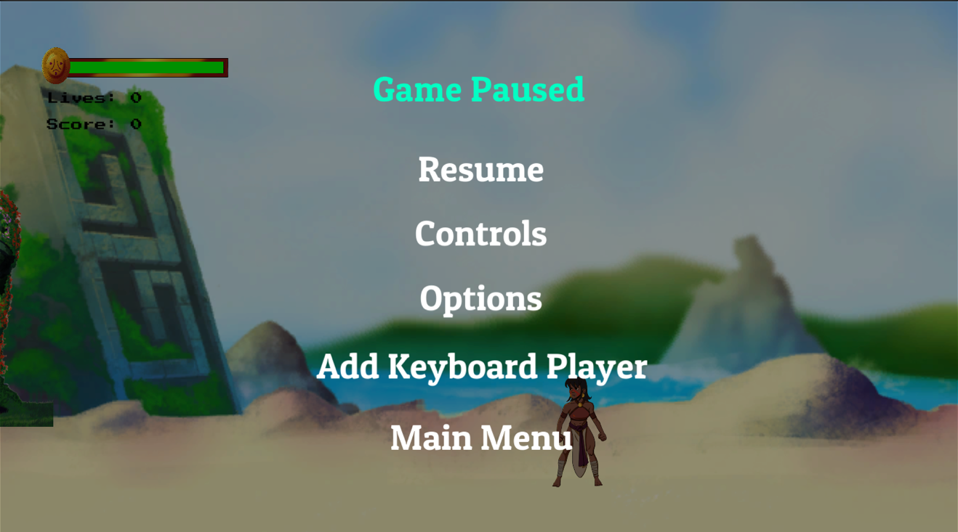

When triggered, time in the game completely stops, and no enemy or player actions can occur. Pause menu buttons can only be selected using the mouse.

The player can:

* Press ‘esc’

Go back to the **Gameplay** screen

* Click ‘Resume’

Go back to the **Gameplay** screen

* Click ‘Controls’

Go to the **Pause – Controls** screen

* Click ‘Options’

Go to the **Pause – Options screen**

* Click ‘Add Keyboard Player’

Spawn in another player controlled with an alternate keyboard scheme detailed in **Pause – Controls**.

Add player number text below each player character

Add health, score, and lives UI to the top right of the screen for player two.

Changes the button to ‘Remove Keyboard Player’

* Click ‘Remove Keyboard Player’

Delete player two from the scene and remove all related UI, including the player number below player one.

* Click ‘Main Menu’

Load **Main Menu** scene

**Pause – Controls**

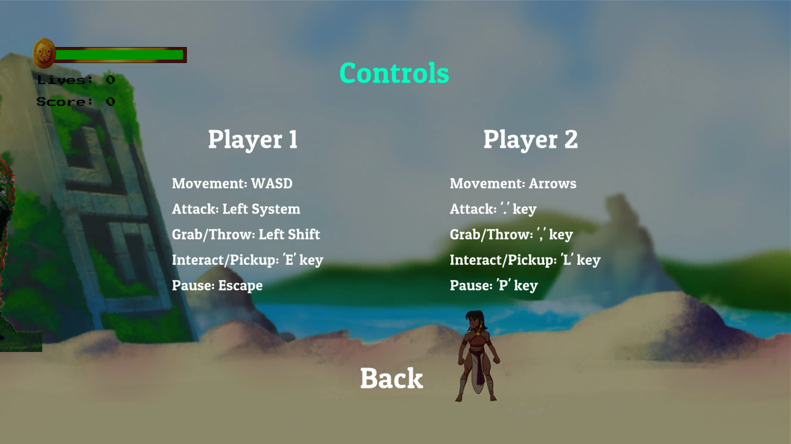

This screen details the keyboard control schemes for each player.

The player can:

* Click ‘Back’

Go back to the **Pause** screen

**Pause - Options**

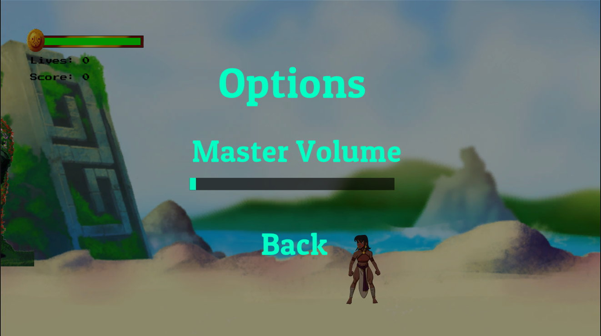

This screen functions exactly the same as the **Options** screen in the main menu, only within the game.

The player can

* Click slider

Drag slider to desired volume setting. Slider changes the value of the master volume with a min of 0 and max of 1

* Select ‘Back’

Go back to **Pause** screen

**Game Over**

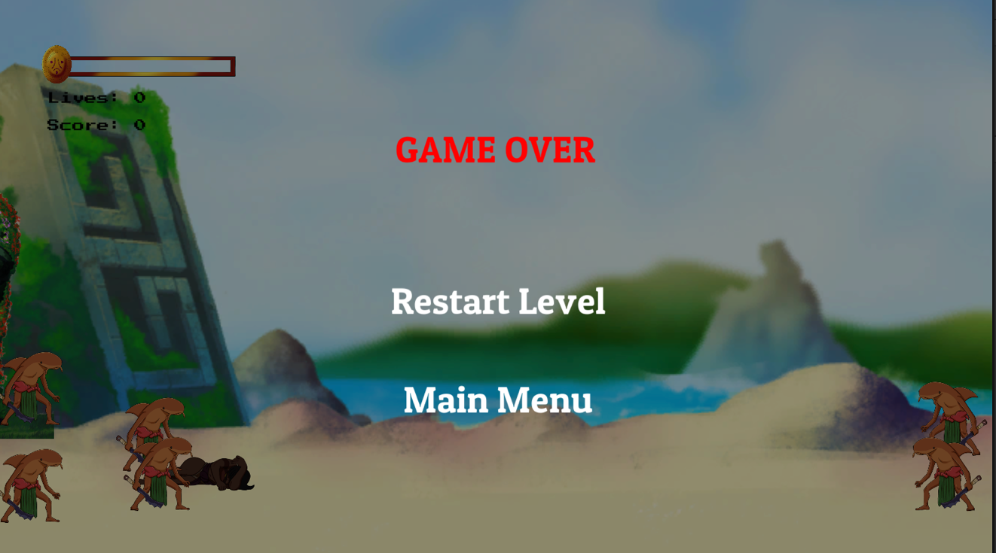

This screen occurs when the player runs out of health and lives. In multiplayer, this screen will occur when both players are dead at the same time.

The player can

* Click ‘Restart Level’

Restart the scene the player is currently in

* Click ‘Main Menu’

Load the **Main Menu** scene.

**Dialogue**

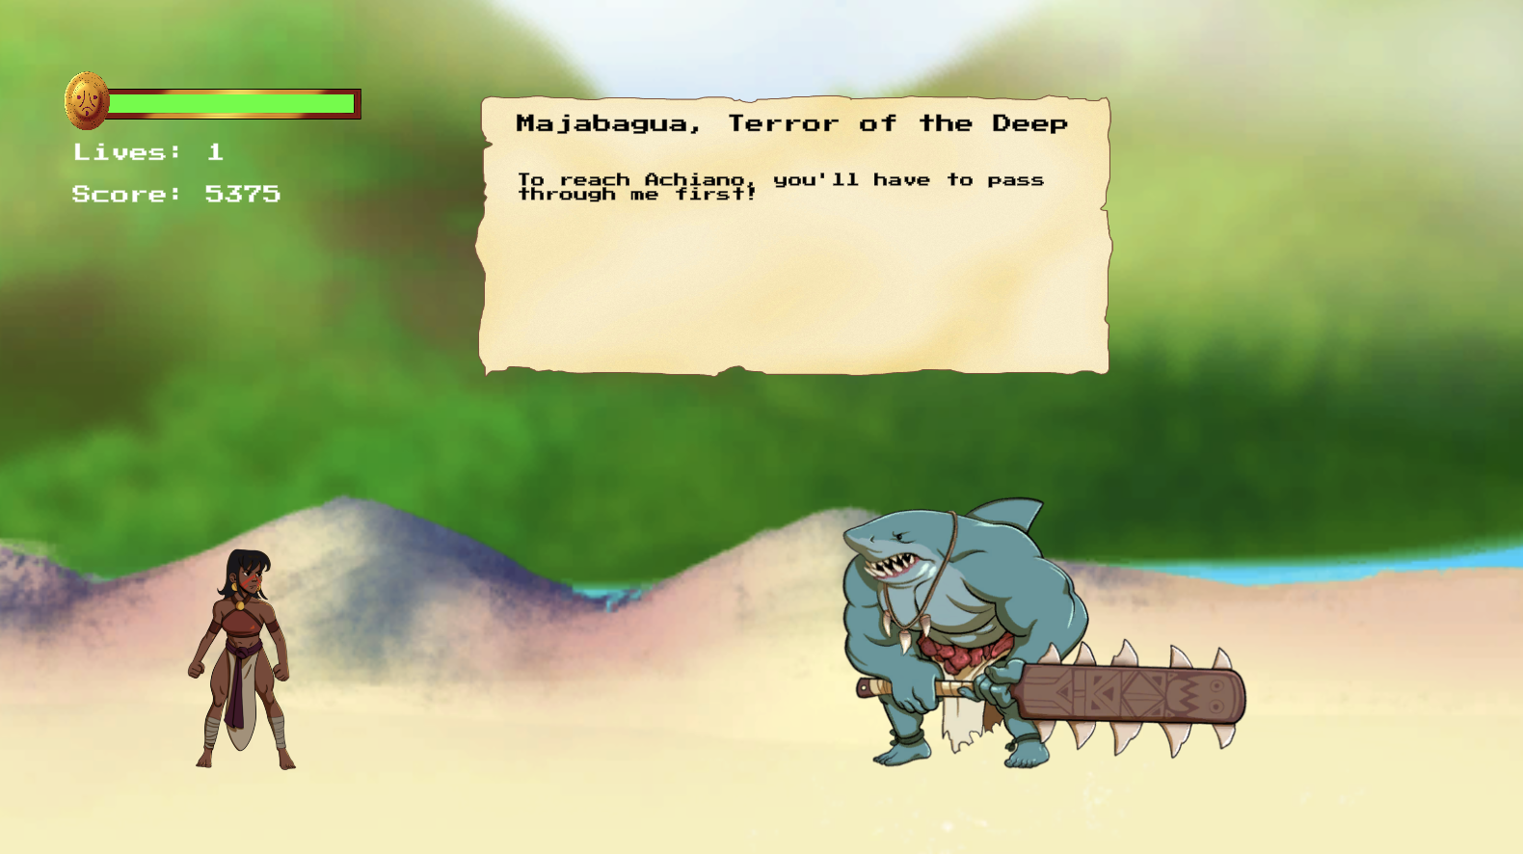

This screen occurs whenever the player enters an invisible dialogue trigger within the scene. The player will lose all control until the dialogue is finished. In boss encounters like the one pictured above, the boss fight will also begin when the dialogue is finished.

The player can

* Press “left system”

Go through dialogue

* Press “esc”

Go to **Pause** screen. Note that because the dialogue box is displayed through the UI canvas, it may overlap pause screen UI.

**Level Complete**

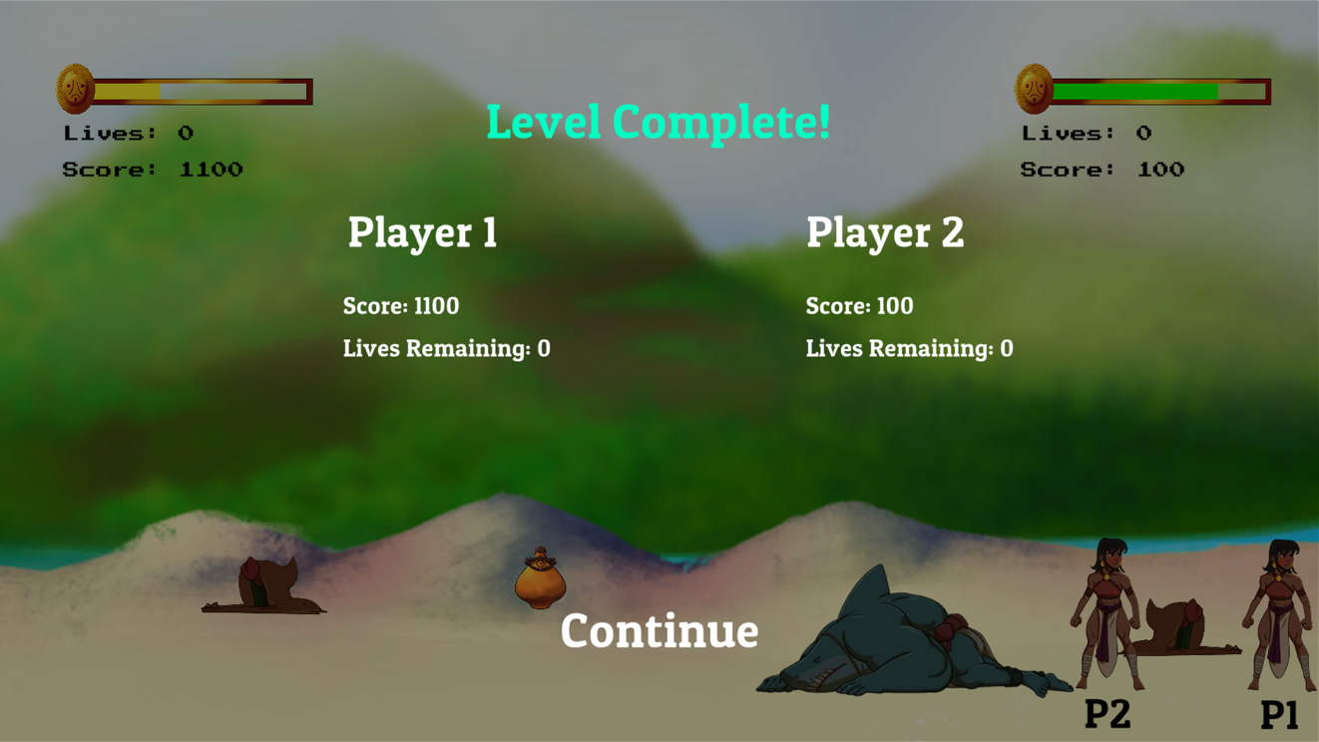

This screen occurs when a player reaches the final collision trigger at the end of the level. It displays the score and lives remaining for each player. In single player, the player 2 UI will not show.

Installation

This section details how to run the product. The simplest method is to run it through the Unity editor. Editors version 2020.3.8f1 LTS and above should work, though only that exact version has been tested. See the requirements section above for details on the hardware needed for running the editor.

**Developer Tools and Source Code Files**

This is the link to the official Unity download page: <https://unity3d.com/get-unity/download>. It is recommended that users first download Unity Hub, and then download the editor through its menus. Version 2020.3.8f1 LTS is only available through the download archive: <https://unity3d.com/get-unity/download/archive>.

To edit the project, users will need to create a Unity project and replace the Assets, Packages, and ProjectSettings folders with those from *The Winds of Boriken* project. They are stored in a private GitHub repository; access can be requested from Paul Smith at [pcsmith221@gmail.com](mailto:pcsmith221@gmail.com).

Below is an example with two Mac Finder windows. The top shows the files that would be provided by Paul Smith, the bottom shows the parent directory of a newly created Unity project. Be sure the new Unity project is not currently running. Simply replace the highlighted folders, and then reload the project.

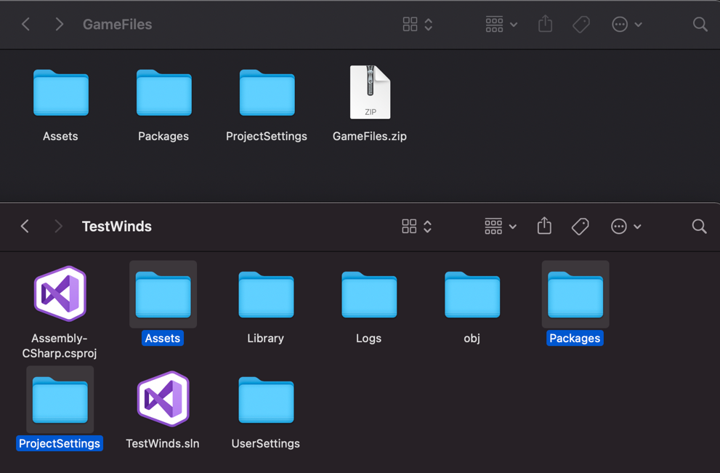

After loading the new project, the first scene will likely be the prototype “Sample Scene” that was used in the early stages of development. Attempting to run this scene will likely result in many errors. Instead, navigate to Assets->Scenes, and select Main Menu. Then, you can press the ‘play’ icon at the top of the screen to run the game.

**Installing for a User**

Because the game is not currently published online, users still need to follow the above steps. After creating a project and loading in the correct folders, first scene will likely be the prototype “Sample Scene” that was used in the early stages of development. Attempting to run this scene will likely result in many errors.

Instead, navigate to Assets->Scenes, and select Main Menu. Then, you can press the ‘play’ icon at the top of the screen to run the game.

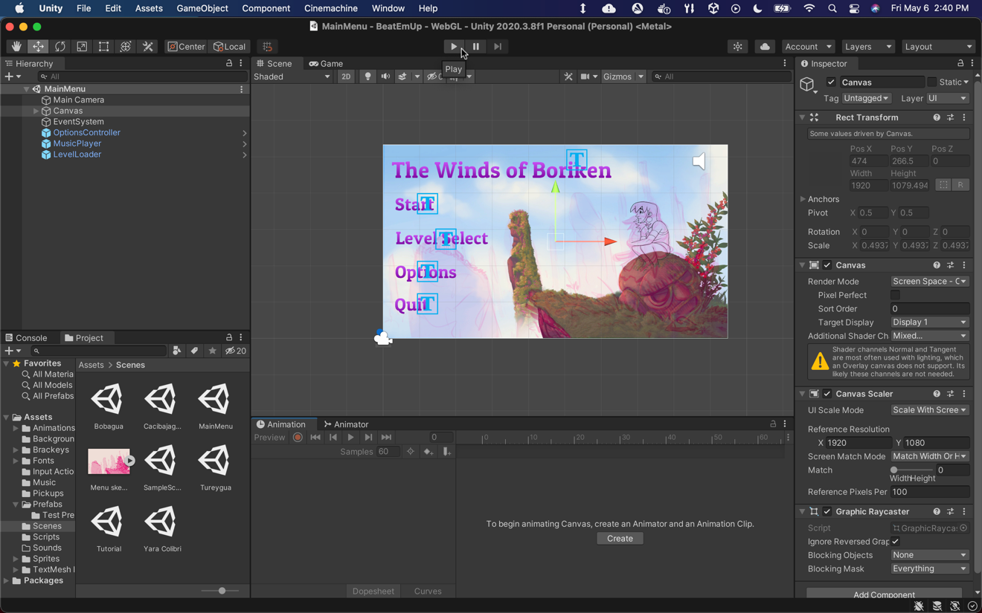

The assets may not look high quality with the default play settings. To fix this, navigate to the game tab tab and ensure “Low Resolution Aspect Ratios” is unchecked. The intended aspect ratio is 16:9.

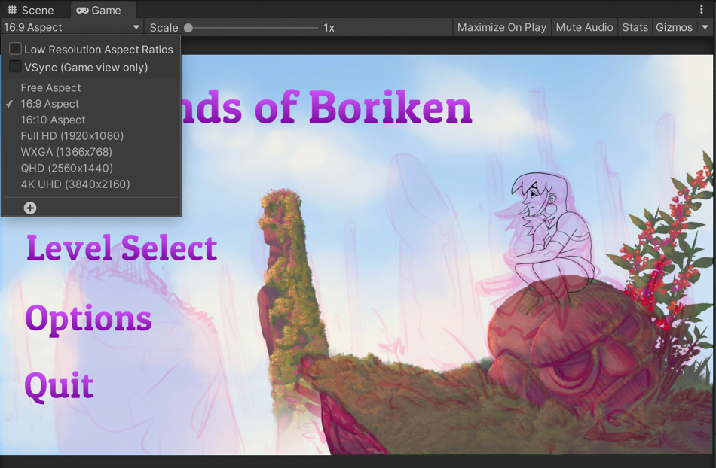

Sample Sessions

This section goes through what a typical session with the game would look like.

There is only one role in this product, the player. Every session begins at the main menu.



Upon entering the tutorial, a dialogue box pops up telling the user basic movement controls. The player can then move through the tutorial, learning the game with similar dialogue triggers. The enemies will not attack the player, they can only take damage, not give it.

You begin the game at the main menu. You can then press ‘Start’ to go straight to the tutorial.

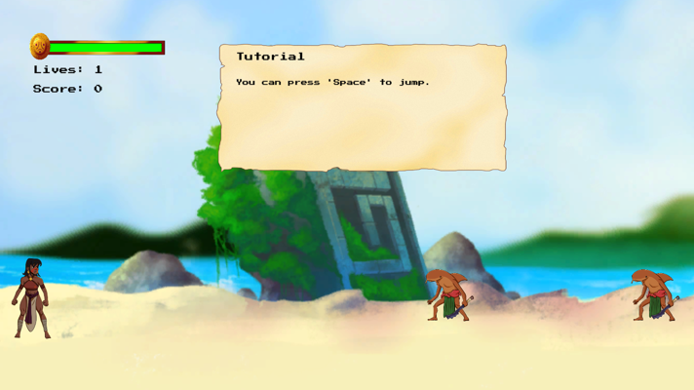

After completing the tutorial you go into the first level, Bobagua, where you will defeat waves of small shark enemies.

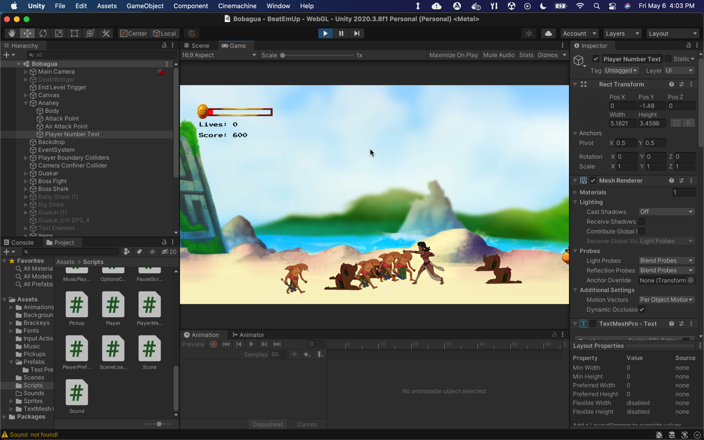

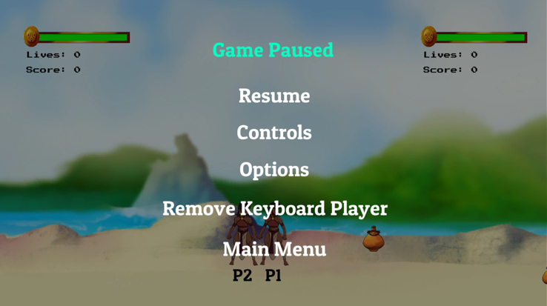

At any time, you can add a second keyboard player. You can then fight through the rest of the level together.

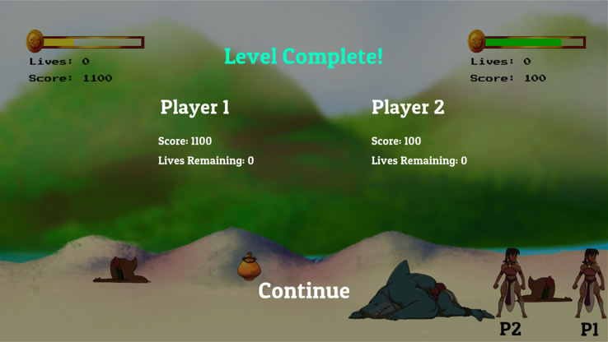

After defeating the final boss and reaching the end, a stats screen displays showing the stats for each player.

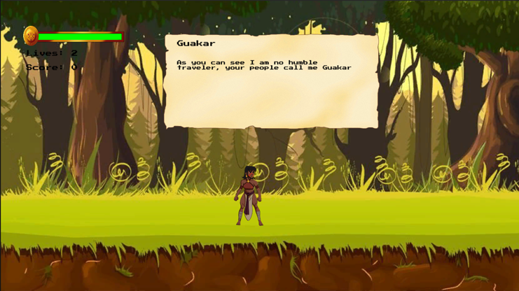

Pressing continue will lead directly to the next level. The game does not keep track of multiplayer between scenes, so you will have to add the other player again if you would like to continue playing cooperatively.

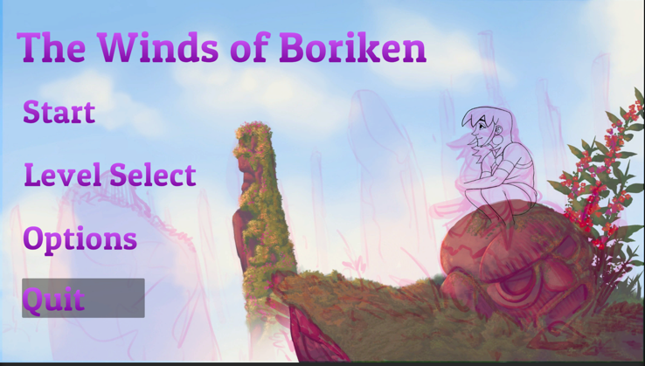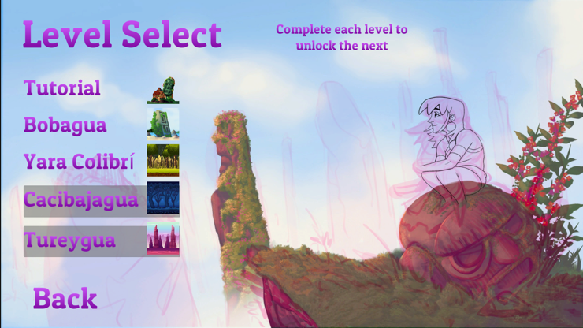

You can then quit using the ‘quit’ button (which does not do anything within the editor).

If you go back to the main menu, you can see that they can now return to the level you left off on. In the current build, all levels start off unlocked for development purposes.

Troubleshooting

The following table shows errors that you might encounter using this product and suggests how to address each one.

|  |  |  |
| --- | --- | --- |
| Problem/Symptom | Possible Cause | Solutions |
| Player will not move | New input system has not been imported to the project | Import the new input system package from Unity. Here are the [instructions](https://docs.unity3d.com/Packages/com.unity.inputsystem@1.0/manual/Installation.html) |
| UI buttons are unclickable | Event system may not be updated to use new input system | Find ‘EventSystem’ in the editor hierarchy and see if the inspector has any options for adjusting the EventSystem |
| Console error: The variable obj of DistanceBetweenTwoObjects has not been assigned. | An enemy is currently in the scene that does not have Anahey assigned to its distance between two objects script. | Find the enemy, then click and drag a game object into the obj field of the distance between two objects script on the enemy in the inspector. |
| Assets look low quality | “Low Resolution Aspect Ratios” is checked | Go to the aspect tab of the game screen and uncheck “Low Resolution Aspect Ratios” |
| Cannot attack | The game was created on Mac and attack was mapped to the “command” button, which is only on Mac devices. | If the left control button does not work, you will need to navigate to Assets->Input Actions in the editor and open the PlayerInputAction asset. Then go to the ‘Attack’ action and create a new binding to the key of your choosing. |
| Player stuck behind invisible boundary | The player collider becomes a trigger while in the air to avoid colliding with the top boundary, and turns back into a physical collider when you hit the ground. This means the player can currently be launched or possibly jump across boundaries they were not meant to cross. | You will need to restart. |

References

Bokaei, Mitra, Intro to Systems Analysis and Design, 2021

Calice, Noa. “Learn the Art of Game Creation.” *Blackthornprod*, https://www.blackthornprod.com/.

Redfield, Carol, Software Engineering, 2022

Team, GameDev.tv, et al. “C# Unity Developer 2D Coding: Learn to Code Video Games.” *Udemy*, Udemy, https://www.udemy.com/course/unitycourse/.

Technologies, Unity. “Unity User Manual 2021.3 (LTS).” *Unity*, https://docs.unity3d.com/Manual/index.html.

Thirslund, Asbjørn. “Game Developer Tutorials.” *Brackeys*, https://brackeys.com/.

Wagner, Bill. “C# Docs - Get Started, Tutorials, Reference.” *C# Docs - Get Started, Tutorials, Reference. | Microsoft Docs*, https://docs.microsoft.com/en-us/dotnet/csharp/.

Wolf, Jeremy. “One Wheel Studio.” *One Wheel Studio*, 2022, https://onewheelstudio.com/.

Source Code File Listings

**Development Interfaces**

**Unity**

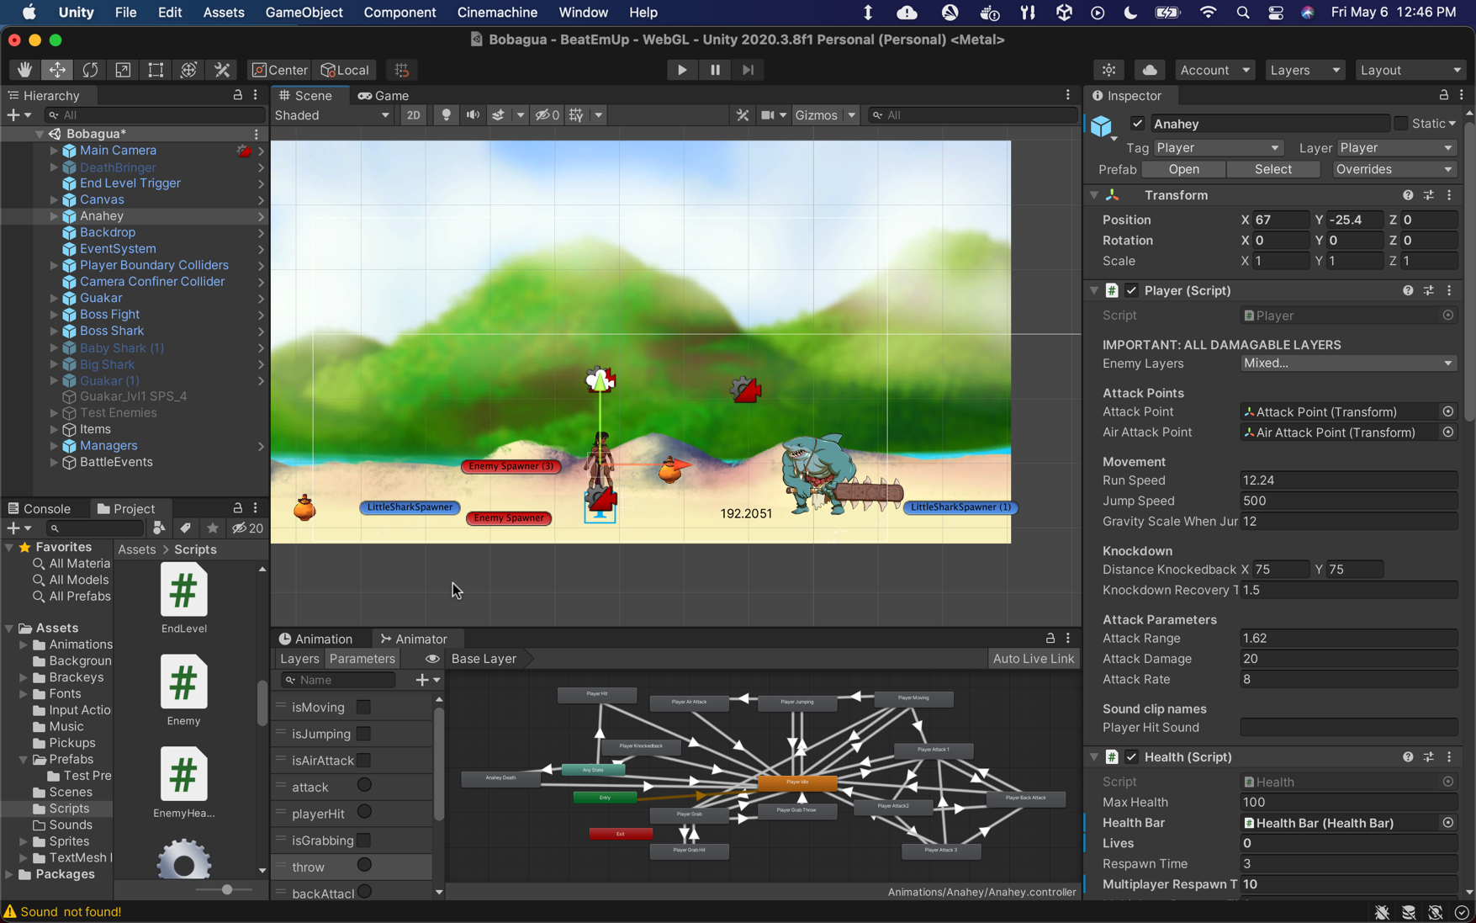

**Visual Studio**

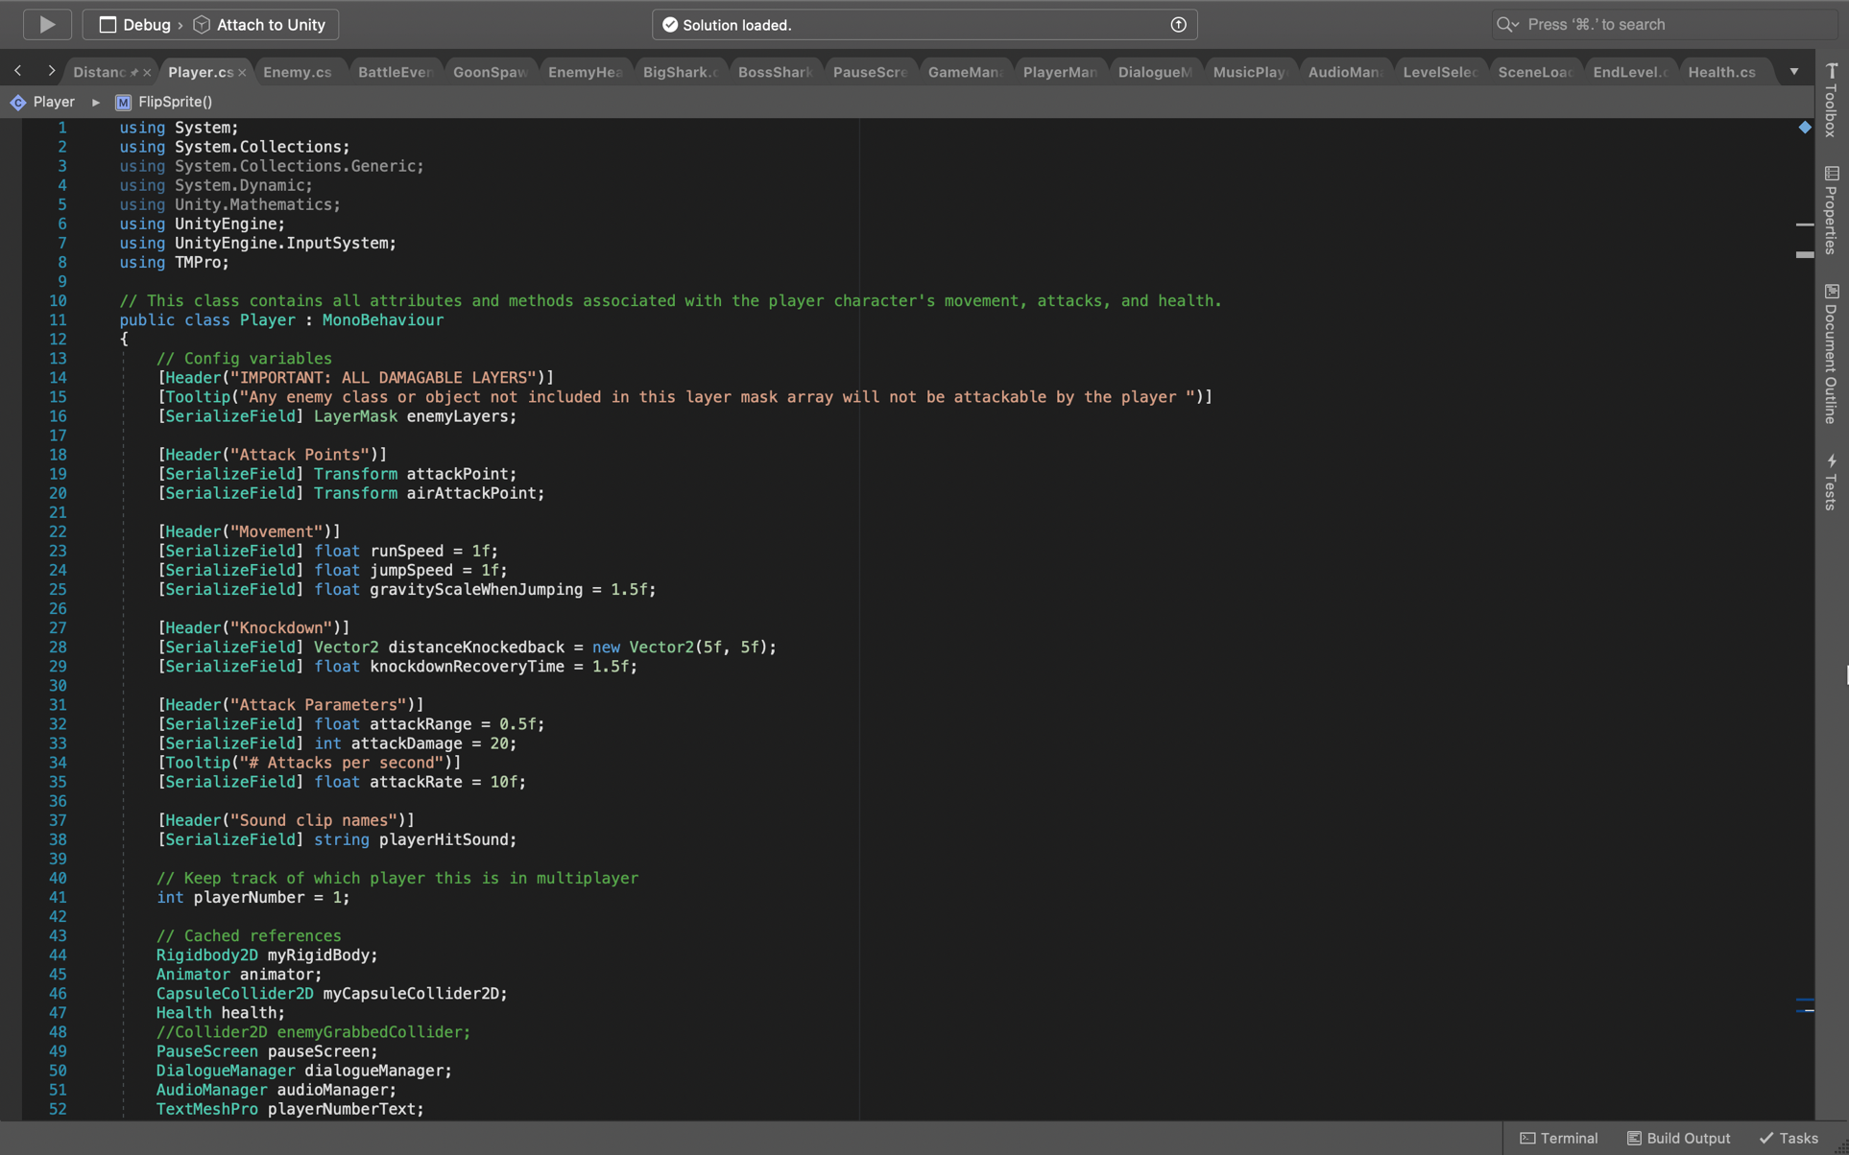

**AudioManager.cs**

using System.Collections;

using System.Collections.Generic;

using UnityEngine;

using System;

// This class is used to store and manage all audio clips in the same place

public class AudioManager : MonoBehaviour

{

[SerializeField] Sound[] sounds;

public static AudioManager instance;

private void Awake()

// Used for initializing an AudioSource for each sound in the Sounds array.

{

// Singleton to ensure that only one AudioManger exists.

if (instance == null)

{

instance = this;

}

else

{

Destroy(gameObject);

return;

}

foreach (Sound sound in sounds)

{

sound.source = gameObject.AddComponent<AudioSource>();

sound.source.clip = sound.clip;

sound.source.volume = sound.volume;

sound.source.pitch = sound.pitch;

sound.source.loop = sound.loop;

}

}

public void Play(string name)

// Play the sound with the given name.

{

Sound sound = Array.Find(sounds, sound => sound.name == name);

if (sound == null)

{

Debug.LogWarning("Sound " + name + " not found!");

}

else

{

sound.source.volume = PlayerPrefsController.GetMasterVolume();

sound.source.Play();

}

}

}

**BattleEvent.cs**

using System.Collections;

using System.Collections.Generic;

using UnityEngine;

using Cinemachine;

using Unity.Mathematics;

// This class adds the functionality for locking the camera, adding new temporary colliders, and activating enemy spawners when the player crosses a given invisible boundary.

// The camera unlocks and the colliders are removed once all enemies are defeated.

public class BattleEvent : MonoBehaviour

{

[Tooltip("Place spawners in scene first then drag to this field")]

[SerializeField] GoonSpawner[] goonSpawners;

[Tooltip("Boundaries the player cannot cross during battles")]

//[SerializeField] Collider2D[] playerColliders;

[SerializeField] GameObject playerColliders;

// Cached reference

CinemachineStateDrivenCamera virtualCamera;

// State variables

int totalNumberOfEnemiesToDefeat = 0;

bool battleStarted = false;

private void Awake()

{

// Ensures battle colliders disabled by default

SetBattleColliders(false);

// Get reference to cinemachine camera controller to disable when battle event starts

virtualCamera = FindObjectOfType<CinemachineStateDrivenCamera>();

}

void Update()

{

if (battleStarted == true)

{

CheckIfAllEnemiesDefeated();

}

}

private void SetBattleColliders(bool isEnabled)

// enable or disable battle colliders

{

foreach (var playerCollider in playerColliders.GetComponentsInChildren<Collider2D>())

{

playerCollider.enabled = isEnabled;

}

}

private void OnTriggerEnter2D(Collider2D collision)

// Starts battle event and enables spawners only if it has not been started already

{

if (battleStarted == false)

{

Debug.Log("Battle event statrted");

SetBattleColliders(true);

var players = FindObjectsOfType<Player>();

foreach (Player player in players)

{

player.SetIsInCombat(true);

}

// prevent camera from moving by disabling it

virtualCamera.enabled = false;

battleStarted = true;

EnableSpawners();

}

}

private void EnableSpawners()

// Enables spawners and adds their enemy count to the total

{

foreach (GoonSpawner spawner in goonSpawners)

{

spawner.enabled = true;

totalNumberOfEnemiesToDefeat += spawner.GetNumberOfEnemiesToSpawn();

StartCoroutine(spawner.StartSpawning());

}

}

private void CheckIfAllEnemiesDefeated()

// Reset camera and level boundaries once all enemies defeated

{

if (totalNumberOfEnemiesToDefeat <= 0)

{

Debug.Log("Battle Event Ended");

virtualCamera.enabled = true;

SetBattleColliders(false);

var players = FindObjectsOfType<Player>();

foreach (Player player in players)

{

player.SetIsInCombat(false);

}

// TODO display go graphic

this.enabled = false;

}

}

public void DecrementEnemy()

// Reduce total when an enemy is defeated

{

totalNumberOfEnemiesToDefeat--;

}

private void DisableSpawners()

// currently not in use, but may be useful if the battle event is made up of conditional spawners that

// will spawn enemies indefinitely until disabled.

{

foreach (GoonSpawner spawner in goonSpawners)

{

spawner.enabled = false;

}

}

}

**BigShark.cs**

using System.Collections;

using System.Collections.Generic;

using UnityEngine;

public class BigShark : Enemy

// inherits from Enemy class to override deal damage method

{

public override void EnemyDealDamage(int damageToDeal)

{

Collider2D[] hitPlayers = Physics2D.OverlapCircleAll(attackPoint.position, damageRange, playerLayers);

foreach (Collider2D player in hitPlayers)

{

//possibly time consuming, possible to cache these references when dealing with unknown number of players?

player.GetComponent<Health>().LoseHealth(damageToDeal);

player.GetComponent<Player>().ProcessHit();

player.GetComponent<Player>().Knockback(Mathf.Sign(transform.localScale.x));

}

}

}

**BossFight.cs**

using System.Collections;

using System.Collections.Generic;

using UnityEngine;

using UnityEngine.UI;

using Cinemachine;

public class BossFight : MonoBehaviour

// Used to trigger in game cinematics, particularly for boss encounters

{

[Header("Cutscene details")]

[SerializeField] Animator cameraAnimator;

[SerializeField] string cutsceneName = "BossCutscene";

[SerializeField] Dialogue dialogue;

[Header("For boss fights")]

[SerializeField] bool isBossFight = true;

[SerializeField] GameObject bossHealthBar;

[SerializeField] Enemy boss;

[SerializeField] GoonSpawner[] enemySpawners;

[SerializeField] GameObject playerBattleColliders;

//[Tooltip("Time in seconds for cutscene")]

//[SerializeField] float cutsceneDuration = 3;

// State variables

bool cutsceneStarted = false;

bool bossFightStarted = false;

// Cahced References

Player player;

CinemachineStateDrivenCamera virtualCamera;

private void Start()

{

boss.GetComponent<Enemy>().enabled = false;

virtualCamera = FindObjectOfType<CinemachineStateDrivenCamera>();

playerBattleColliders.SetActive(false);

}

private void Update()

{

if (cutsceneStarted && !bossFightStarted)

{

// Once the player finishes dialogue they will no longer be disabled and the camera should go back to the player

if (!player.GetIsDisabled())

{

StopCutscene();

}

}

}

private void OnTriggerEnter2D(Collider2D collision)

{

// Only players can start the cutscene, and only if it has not been activated yet

if (collision.gameObject.CompareTag("Player") && !cutsceneStarted)

{

player = collision.GetComponent<Player>();

cameraAnimator.SetBool(cutsceneName, true);

FindObjectOfType<DialogueManager>().StartDialogue(dialogue);

cutsceneStarted = true;

}

}

private void StopCutscene()

// Ends the cutscene and starts the boss fight if there is one

{

cameraAnimator.SetBool(cutsceneName, false);

Debug.Log("Stop Cutscene called");

if (isBossFight)

{

bossFightStarted = true;

StartBossFight();

}

}

private void StartBossFight()

// Similar to battle event, lock player in new boundaries until boss defeated

{

Debug.Log("Start boss fight called");

bossHealthBar.SetActive(true);

boss.GetComponent<Enemy>().enabled = true;

virtualCamera.enabled = false;

playerBattleColliders.SetActive(true);

foreach(var spawner in enemySpawners)

{

StartCoroutine(spawner.StartSpawning());

}

}

private void OnEnable()

// Subscribes to boss died event in game manager

{

GameManager.bossDied += BossDefeated;

}

private void OnDisable()

// Unsubscribes from boss died event in game manager

{

GameManager.bossDied -= BossDefeated;

}

private void BossDefeated()

// Stop battle event and allow player to move on

{

Debug.Log("Boss Defeated");

foreach (var spawner in enemySpawners)

{

spawner.StopSpawning();

StopCoroutine(spawner.StartSpawning());

spawner.enabled = false;

}

playerBattleColliders.SetActive(false);

bossHealthBar.SetActive(false);

virtualCamera.enabled = true;

}

}

**BossHealthBar.cs**

using System.Collections;

using System.Collections.Generic;

using UnityEngine;

using UnityEngine.UI;

// Displays and updates healthbar for boss

public class BossHealthBar : MonoBehaviour

{

public EnemyHealth bossHealth;

public Slider slider;

void Start()

{

slider.maxValue = bossHealth.GetMaxHealth();

}

// Update is called once per frame

void Update()

{

slider.value = bossHealth.GetCurrentHealth();

if (bossHealth.GetCurrentHealth() <= 0)

{

Destroy(gameObject);

}

}

}

**BossSharkHealth.cs**

using System;

using System.Collections;

using System.Collections.Generic;

using UnityEngine;

// Boss Shark needs special behavior for notifying the game manager that the boss is defeated.

public class BossSharkHealth : EnemyHealth

{

public override void Die()

{

base.Die();

FindObjectOfType<GameManager>().BossDefeated();

}

public override void Knockback()

// Big shark enemies cannot be knocked back

{

return;

}

}

**Breakable.cs**

using System.Collections;

using System.Collections.Generic;

using UnityEngine;

// Behavior for displaying damage level of breakable objects and spawning an item when it breaks

public class Breakable : MonoBehaviour

{

// Configuration parameters

[SerializeField] Pickup pickup;

[SerializeField] Sprite[] hitSprites;

[Tooltip("How many hits it takes to reach the next damage level")]

[SerializeField] int hitsPerDamageLevel = 1;

// State variables

int maxHits;

public int damageLevel;

int spriteIndex = 0;

// Chached references

AudioManager audioManager;

SpriteRenderer spriteRenderer;

private void Start()

// Initialize maxHits and cache references

{

maxHits = (hitSprites.Length + 1) * hitsPerDamageLevel;

audioManager = FindObjectOfType<AudioManager>();

spriteRenderer = GetComponent<SpriteRenderer>();

}

public void HandleHit()

// Increase damage level and determine if need to break or show next hit sprite

{

audioManager.Play("Hit Breakable");

damageLevel++;

if (damageLevel >= maxHits)

{

Break();

}

else if (damageLevel % hitsPerDamageLevel == 0)

{

ShowNextHitSprite();

}

}

private void Break()

// Spawn pickup and destroy object.

{

audioManager.Play("Broke Breakable");

Instantiate(pickup, transform.position, transform.rotation);

Destroy(gameObject);

}

private void ShowNextHitSprite()

// Change sprite to next damage level.

{

if (hitSprites[spriteIndex] != null)

{

spriteRenderer.sprite = hitSprites[spriteIndex];

}

else

{

Debug.LogError("Block sprite is missing from array " + gameObject.name);

}

spriteIndex++;

}

}

**DeathBringer.cs**

using System.Collections;

using System.Collections.Generic;

using UnityEngine;

// DeathBringer sprite sheet was facing left instead of right, so this enemies flipping behavior must be reversed.

public class DeathBringer : Enemy

{

public override void FlipSprite()

{

base.ReverseFlipSprite();

}

}

**Dialogue.cs**

using System.Collections;

using System.Collections.Generic;

using UnityEngine;

// This class contains the name and sentences of dialogue for a character that is configured and started by a DialogueTrigger

[System.Serializable]

public class Dialogue

{

[SerializeField] string name;

[TextArea(3,10)]

[SerializeField] string[] sentences;

public string[] GetSentences()

{

return sentences;

}

public string GetName()

{

return name;

}

}

**DialogueManager.cs**

using System.Collections;

using System.Collections.Generic;

using UnityEngine;

using TMPro;

// This class controls the functionality of the dialogue box UI

public class DialogueManager : MonoBehaviour

{

[SerializeField] TextMeshProUGUI nameText;

[SerializeField] TextMeshProUGUI dialogueText;

[SerializeField] Animator animator;

Queue<string> sentences;

// Start is called before the first frame update

void Start()

{

sentences = new Queue<string>();

}

public void StartDialogue(Dialogue dialogue)

// Brings down dialogue UI and disables player until dialogue is finished.

{

//Time.timeScale = 0f;

var players = FindObjectsOfType<Player>();

foreach (Player player in players)

{

player.SetIsDisabled(true);

}

animator.SetBool("isOpen", true);

nameText.text = dialogue.GetName();

sentences.Clear();

foreach (string sentence in dialogue.GetSentences())

{

sentences.Enqueue(sentence);

}

DisplayNextSentence();

}

public void DisplayNextSentence()

{

if (sentences.Count == 0)

{

EndDialogue();

return;

}

string sentence = sentences.Dequeue();

// If sentence already running, ensure current coroutine is stopped

StopAllCoroutines();

StartCoroutine(TypeSentence(sentence));

}

IEnumerator TypeSentence(string sentence)

// Type sentence out letter by letter with a frame duration between each letter

{

dialogueText.text = "";

foreach (char letter in sentence.ToCharArray())

{

dialogueText.text += letter;

yield return null;

}

}

void EndDialogue()

// Remove dialogue box and enable player

{

animator.SetBool("isOpen", false);

var players = FindObjectsOfType<Player>();

foreach (Player player in players)

{

player.SetIsDisabled(false);

}

//Time.timeScale = 1f;

}

}

**DialogueTrigger.cs**

using System;

using System.Collections;

using System.Collections.Generic;

using UnityEngine;

// Triggers dialogue automatically after player passes through collider. Also provides functionality to replay dialogue if player is in range and presses the interact button

public class DialogueTrigger : MonoBehaviour

{

[SerializeField] Dialogue dialogue;

// State variable

bool inDialogueRange;

bool triggeredAlready = false;

private void ReplayDialogue()

// Allow player to trigger dialogue again manually.

{

if (inDialogueRange)

{

TriggerDialogue();

}

}

private void OnTriggerEnter2D(Collider2D collision)

{

if (collision.gameObject.CompareTag("Player") && !collision.GetComponent<Player>().GetIsInCombat() && !triggeredAlready)

{

inDialogueRange = true;

triggeredAlready = true;

TriggerDialogue();

}

else if (collision.gameObject.CompareTag("Player"))

{

inDialogueRange = true;

}

}

private void OnTriggerExit2D(Collider2D collision)

{

if (collision.gameObject.CompareTag("Player"))

{

inDialogueRange = false;

}

}

public void TriggerDialogue()

// Start the dialogue associated with this trigger in the dialogue manager.

{

// Disables speech bubble animation if there is one

if (gameObject.transform.childCount != 0)

{

GetComponentInChildren<Animator>().enabled = false;

}

FindObjectOfType<DialogueManager>().StartDialogue(dialogue);

}

private void OnEnable()

// Subscribes to pauseGame event in Player script

{

Player.interact += ReplayDialogue;

}

private void OnDisable()

// Unsubscribes from pauseGame event should the script become disabled

{

Player.interact -= ReplayDialogue;

}

}

**DistanceBetweenTwoObjects.cs**

using System.Collections;

using System.Collections.Generic;

using UnityEngine;

using UnityEditor;

// Visualizes the distance between two objects in the Unity Editor.

[ExecuteInEditMode]

public class DistanceBetweenTwoObjects : MonoBehaviour

{

public GameObject obj;

public float distanceBetweenObjects;

private void Update()

{

distanceBetweenObjects = Vector3.Distance(transform.position, obj.transform.position);

Debug.DrawLine(transform.position, obj.transform.position, Color.green);

}

private void OnDrawGizmos()

{

GUI.color = Color.black;

Handles.Label(transform.position - (transform.position -

obj.transform.position) / 2, distanceBetweenObjects.ToString());

}

}

**EndLevel.cs**

using System.Collections;

using System.Collections.Generic;

using UnityEngine;

using UnityEngine.SceneManagement;

using TMPro;

// This class loads the level complete screen when the player reaches the end of a level

// Just loads next scene if the current level is the tutorial

public class EndLevel : MonoBehaviour

{

[SerializeField] GameObject levelCompleteScreen;

[SerializeField] GameObject p1Stats;

[SerializeField] GameObject p2Stats;

string tutorialSceneName = "Tutorial";

bool inTutorial = false;

private void Start()

// Checks if the current scene is the tutorial

{

var currentScene = SceneManager.GetActiveScene();

if (currentScene.name == tutorialSceneName)

{

inTutorial = true;

}

}

private void OnTriggerEnter2D(Collider2D collision)

// Handles player entering the end level game object's collider

{

if(inTutorial)

{

FindObjectOfType<SceneLoader>().LoadNextScene();

}

else

{

Time.timeScale = 0f;

levelCompleteScreen.SetActive(true);

ShowPlayerStats();

}

}

private void ShowPlayerStats()

// Populate the stats for each player

{

var players = FindObjectsOfType<Player>();

foreach (var player in players)

{

player.SetIsDisabled(true);

switch (player.GetPlayerNumber())

{

case 1:

p1Stats.SetActive(true);

var p1Text = GameObject.FindGameObjectWithTag("P1 Stats").GetComponent<TextMeshProUGUI>();

p1Text.text = "Score: " + player.GetComponent<Score>().GetScore() +

"\nLives Remaining: " + player.GetComponent<Health>().GetLives();

break;

case 2:

p2Stats.SetActive(true);

var p2Text = GameObject.FindGameObjectWithTag("P2 Stats").GetComponent<TextMeshProUGUI>();

p2Text.text = "Score: " + player.GetComponent<Score>().GetScore() +

"\nLives Remaining: " + player.GetComponent<Health>().GetLives();

break;

default:

Debug.LogError("No stats box found");

break;

}

}

}

}

**Enemy.cs**

using System.Collections;

using System.Linq;

using System.Collections.Generic;

using Unity.Mathematics;

using UnityEngine;

// Class that controls enemy movement and attacks.

public class Enemy : MonoBehaviour

{

//configuration variables

[Header("Movement")]

[SerializeField] float moveSpeed = 2f;

[SerializeField] Vector2 roamDistance = new Vector2(1.0f, 3f);

[Header("Decision times X: Min, Y: Max")]

[SerializeField] Vector2 attackDecisionTime = new Vector2(1.0f, 1.5f); //original 1.0f, 1.5f

[SerializeField] Vector2 waitDecisionTime = new Vector2(0.2f, 0.5f); //original 0.2f, 0.5f

[SerializeField] Vector2 roamDecisionTime = new Vector2(.3f, .6f); //original 0.3f, 0.6f

[SerializeField] Vector2 chaseDecisionTime = new Vector2(.2f, .4f); //original: 0.2f, 0.4f

[Header("Targeting and Attacking")]

[SerializeField] protected LayerMask playerLayers;

[SerializeField] protected Transform attackPoint;

[Tooltip("The distance in which the enemy will begin to target and chase after the player")]

[SerializeField] float targetRange = 100f;

[SerializeField] float stoppingDistance = .2f; //stopping distance is separate from attack range in case I want enemies to attack from farther away?

[Tooltip("Radius in which enemy attacks will deal damage")]

[SerializeField] protected float damageRange = .5f;

[Tooltip("Radius where enemy will begin attacking")]

[SerializeField] float attackRange = 1f;

[SerializeField] int attackDamage = 20; //Attack damage configured within animation event

[Tooltip("# Attacks per second")]

[SerializeField] float attackRate = 1f;

//state variables

Player currentTarget = null;

Health currentTargetHealth;

float nextAttackTime = 0f;

//List<float> playerDistances;

Dictionary<Player, float> playerDistances;

float decisionDuration;

Vector3 roamDestination;

int isHit = 0;

int isGroundAttacking = 0;

bool inMultiplayer = false;

PlayerManager playerManager;

bool isChasingPlayer = false;

bool isRoaming = false;

bool canMakeDecision = true;

//cached references

Animator animator;

EnemyHealth enemyHealth;

Rigidbody2D rb;

public enum EnemyState

{

waiting,

recovering,

roaming,

chasing,

attacking,

}

EnemyState currentState;

public class DecisionWeight

{

public int weight;

public EnemyState state;

public DecisionWeight(int weight, EnemyState action)

{

this.weight = weight;

state = action;

}

}

List<DecisionWeight> weights;

// Start is called before the first frame update

void Start()

{

// Create data structures

weights = new List<DecisionWeight>();

playerDistances = new Dictionary<Player, float>();

// Get component references

animator = GetComponent<Animator>();

enemyHealth = GetComponent<EnemyHealth>();

rb = GetComponent<Rigidbody2D>();

playerManager = FindObjectOfType<PlayerManager>();

inMultiplayer = playerManager.InMultiplayer();

if (inMultiplayer)

{

// Get initial target

UpdateTarget();

}

else

{

currentTarget = FindObjectOfType<Player>();

currentTargetHealth = currentTarget.GetComponent<Health>();

}

}

private void Update()

{

if (!enemyHealth.IsDisabled())

{

UpdateState();

FlipSprite();

//Debug.Log("decision duration = " + decisionDuration);

HandleDecisions();

ChasePlayer();

Roaming();

if (inMultiplayer)

{

UpdateTarget();

}

}

}

private void UpdateTarget()

// Rebuild targeting dictionary to target the closest player

{

playerDistances.Clear();

// Create array of all players and build distance dictionary of alive players

var players = FindObjectsOfType<Player>();

foreach (var player in players)

{

if (player.GetComponent<Health>().GetIsAlive())

{

playerDistances.Add(player, Vector3.Distance(transform.position, player.transform.position));

}

}

if (playerDistances.Count > 0)

{

// Make current target the closest player

var minDistance = playerDistances.Values.Min();

// Lambda expression that gets player key that has the min distance

currentTarget = playerDistances.FirstOrDefault(p => p.Value == minDistance).Key;

currentTargetHealth = currentTarget.GetComponent<Health>();

}

else

{

currentState = EnemyState.waiting;

DoStateAction();

}

}

private void HandleDecisions()

// Keeps enemy in current state until the time they can make a decision again.

{

if (decisionDuration > 0.0f)

{

decisionDuration -= Time.deltaTime;

canMakeDecision = false;

}

else

{

isRoaming = false;

isChasingPlayer = false;

canMakeDecision = true;

}

}

private void UpdateState()

// Decides which weights to give different states based on whether the enemy is within attack range or not, then calls decision method.

{

if (isHit == 1 || isGroundAttacking == 1 || !enemyHealth.IsRecovered()) //simply take out isHit condition for enemies w/out stagger

{

animator.SetBool("isChasing", false);

isRoaming = false;

isChasingPlayer = false;

return;

}

else if (canMakeDecision)

{

//for reference: DecideWithWeights(int attack, int wait, int chase, int roam)

if (!currentTargetHealth.GetIsAlive())

// Current Target died

// Redundant in multiplayer since targeting script finds alive players

{

currentState = EnemyState.waiting;

DoStateAction();

}

// If player is within targeting range but outside attack range, or player is knocked down: chase, wait, or roam.

else if ((Vector2.Distance(transform.position, currentTarget.transform.position) > attackRange) &&

(Vector2.Distance(transform.position, currentTarget.transform.position) > stoppingDistance) && //stop enemy from wanting to travel into player

(Vector2.Distance(transform.position, currentTarget.transform.position) < targetRange) ||

currentTarget.GetIsKnockedback())

{

DecideWithWeights(0, 10, 70, 10);

DoStateAction();

}

else if (Vector2.Distance(transform.position, currentTarget.transform.position) <= attackRange)

{

DecideWithWeights(80, 10, 0, 10); //attack, wait, or roam. Default: (70, 15, 0, 15)

DoStateAction();

}

else

// No target in range

{

currentState = EnemyState.waiting;

DoStateAction();

}

}

}

private void DecideWithWeights(int attackWeight, int waitWeight, int chaseWeight, int roamWeight)

// The way this works is that each enemy state has an associated weight. Each weight gets added together. A random value is then selected between 0 and the total.

// Each state then subtracts its weight from that value. Whichever state gets the decision value to zero becomes the current state. The higher the weight, the more

// likely that state will become the new enemy state.

{

weights.Clear();

//Debug.Log("Making decision");

if (attackWeight > 0)

weights.Add(new DecisionWeight(attackWeight, EnemyState.attacking));

if (chaseWeight > 0)

weights.Add(new DecisionWeight(chaseWeight, EnemyState.chasing));

if (waitWeight > 0)

weights.Add(new DecisionWeight(waitWeight, EnemyState.waiting));

if (roamWeight > 0)

weights.Add(new DecisionWeight(roamWeight, EnemyState.roaming));

int total = attackWeight + chaseWeight + waitWeight + roamWeight;

int intDecision = UnityEngine.Random.Range(0, total - 1);

foreach (DecisionWeight weight in weights)

{

intDecision -= weight.weight;

if (intDecision <= 0)

{

currentState = weight.state;

//Debug.Log("Current state = " + currentState);

break;

}

}

}

private void DoStateAction()

// Call the method associated with the current state.

{

switch (currentState)

{

case EnemyState.chasing:

Chase();

break;

case EnemyState.roaming:

Roam();

break;

case EnemyState.attacking:

Attack();

break;

case EnemyState.waiting:

Wait();

break;

default:

break;

}

}

private void Wait()

// Simply reset the decision time and do nothing.

{

decisionDuration = UnityEngine.Random.Range(waitDecisionTime.x, waitDecisionTime.y);

animator.SetBool("isChasing", false);

}

private void Chase()

// Changes player state to chasing. Movement handled by ChasePlayer() method as it needs to be continuously called in Update().

{

isChasingPlayer = true;

decisionDuration = UnityEngine.Random.Range(chaseDecisionTime.x, chaseDecisionTime.y);

}

private void ChasePlayer()

// Moves enemy towards the player.

{

if (isChasingPlayer)

{

animator.SetBool("isChasing", true);

transform.position = Vector2.MoveTowards(transform.position, currentTarget.transform.position, moveSpeed * Time.deltaTime);

}

}

private void Roam()

// Decides location for Enemy to roam to in the Roaming() method.

{

isRoaming = true;

float randomDegree = UnityEngine.Random.Range(0, 360);

Vector2 offset = new Vector2(Mathf.Sin(randomDegree), Mathf.Cos(randomDegree));

float distance = UnityEngine.Random.Range(roamDistance.x, roamDistance.y);

offset *= distance;

Vector3 directionVector = new Vector3(offset.x, offset.y, 0);

roamDestination = transform.position + directionVector;

decisionDuration = UnityEngine.Random.Range(roamDecisionTime.x, roamDecisionTime.y);

}

private void Roaming()

// Moves enemy towards the random destination decided in the Roam() method.

{

if (isRoaming)

{

animator.SetBool("isChasing", true);

transform.position = Vector2.MoveTowards(transform.position, roamDestination, moveSpeed * Time.deltaTime);

}

}

public virtual void Attack()

// Trigger attack animation if enemy is able to attack again.

{

animator.SetBool("isChasing", false);

if (Time.time >= nextAttackTime)

{

animator.SetTrigger("attack");

nextAttackTime = Time.time + (1f / attackRate);

}

decisionDuration = UnityEngine.Random.Range(attackDecisionTime.x, attackDecisionTime.y);

}

public virtual void EnemyDealDamage(int damageToDeal)

// Called through animation event during attack animation.

{

Collider2D[] hitPlayers = Physics2D.OverlapCircleAll(attackPoint.position, damageRange, playerLayers);

foreach (Collider2D player in hitPlayers)

{

//possibly time consuming, possible to cache these references when dealing with unknown number of players?

player.GetComponent<Health>().LoseHealth(damageToDeal);

player.GetComponent<Player>().ProcessHit();

}

}

public void SetIsHit(int isHit)

// Sets isHit state variable from hit animation. Animation events cant use functions with bool parameters.

{

if ((isHit == 1) || (isHit == 0))

{

this.isHit = isHit;

}

else

{

Debug.LogError("SetIsHit passed a value not one or zero");

}

}

public void SetIsGroundAttacking(int isGroundAttacking)

// Sets isGroundAttacking state variable from hit animation. Animation events cant use functions with bool parameters.

{

if ((isGroundAttacking == 1) || (isGroundAttacking == 0))

{

this.isGroundAttacking = isGroundAttacking;

}

else

{

Debug.LogError("SetIsGroundAttacking passed a value not one or zero");

}

}

public Player GetCurrentTarget()

{

return currentTarget;

}

public virtual void FlipSprite()

// Changes the x value based on the direction the player is moving ('+' = right, '-' = left)

{

if (!currentTarget)

{

return;

}

if ((transform.position.x - currentTarget.transform.position.x) >= Mathf.Epsilon)

{

transform.localScale = new Vector3(-1, 1, 1);

}

else

{

transform.localScale = new Vector3(1, 1, 1);

}

}

public virtual void ReverseFlipSprite()

// FlipSprite() reversed for sprite sheets that start with character looking left

{

if (!currentTarget)

{

return;

}

if ((transform.position.x - currentTarget.transform.position.x) >= Mathf.Epsilon)

{

transform.localScale = new Vector3(1, 1, 1);

}

else

{

transform.localScale = new Vector3(-1, 1, 1);

}

}

private void OnEnable()

// Subscribes to multiplayer events in PlayerManager script

{

PlayerManager.startedMultiplayer += StartMultiTargeting;

PlayerManager.endedMultiplayer += StopMultiTargeting;

}

private void StartMultiTargeting()

{

inMultiplayer = true;

}

private void StopMultiTargeting()

{

inMultiplayer = false;

}

private void OnDisable()

// Unsubscribes from multiplayer events in PlayerManager script

{

PlayerManager.startedMultiplayer -= StartMultiTargeting;

PlayerManager.endedMultiplayer -= StopMultiTargeting;

}

private void OnDrawGizmosSelected()

// Visualizes damage and targeting ranges in the inspector for easier adjusting in the editor

{

Gizmos.DrawWireSphere(transform.position, targetRange);

Gizmos.color = Color.red;

Gizmos.DrawWireSphere(attackPoint.position, damageRange);

}

}

**EnemyHealth.cs**

using System;

using System.Collections;

using System.Collections.Generic;

using UnityEngine;

// Class that manages Enemy health and grabbed states.

public class EnemyHealth : MonoBehaviour

{

[SerializeField] string hitSound;

[SerializeField] string deathSound;

[SerializeField] string hitGroundSound;

[Header("Health Parameters")]

[SerializeField] int maxHealth = 100;

[SerializeField] int scoreForDefeating = 100;

[SerializeField] float gravityScaleWhenThrown = 1.5f;

[SerializeField] float recoveryTime = 2f;

[SerializeField] bool isGrabbable = true;

[SerializeField] bool staggerOnHit = true;

[SerializeField] bool isKnockbackable = true;

[SerializeField] int hitGroundDamage = 10;

[Header("Knockback/grab Parameters")]

[Tooltip("Enemies that will get knocked down if this thrown into them")]

[SerializeField] LayerMask enemyLayers;

[SerializeField] Transform knockbackOtherEnemiesPoint;

[Tooltip("Other enemies caught in this range will be knocked back when this enemy is thrown")]

[SerializeField] float knockbackOtherEnemiesRange = .5f;

public Vector2 distanceKnockedback = new Vector2(5f, 5f);

[SerializeField] float knockdownRecoveryTime = 1.5f;

public Vector2 distanceThrownByPlayer = new Vector2(25f, 25f);

public float grabPositionXOffset = 1f;

// State variables

int currentHealth;

bool isGrabbed = false;

bool isBeingThrown = false;

bool isBeingKnockedback = false;

bool isKnockedback = false;

float yThrownPosition;

float timeCanMoveAgain = 0f;

Player playerMostRecentlyAttackedBy; // for correct individual scoring

// Cached references

Animator animator;

Rigidbody2D rb;

Collider2D myCollider2D;

BattleEvent battleEvent;

AudioManager audioManager;

private void Start()

{

currentHealth = maxHealth;

animator = GetComponent<Animator>();

rb = GetComponent<Rigidbody2D>();

myCollider2D = GetComponent<Collider2D>();

audioManager = FindObjectOfType<AudioManager>();

// The only enemies that have a parent transform are those spawned within a battle event. This allows me to leave enemies outside battle events.

if(transform.parent)

{

battleEvent = GetComponentInParent<BattleEvent>();

}

}

public bool IsDisabled()

// If any state variables are true, enemy script should not update.

{

return (isGrabbed || isBeingThrown || isBeingKnockedback || isKnockedback);

}

private void FixedUpdate()

{

if (isBeingThrown)

{

// Only thrown enemies can knock back other enemies to avoid domino effect

KnockbackCollision();

HitGround();

}

else if (isBeingKnockedback)

{

HitGround();

}

}

private void KnockbackCollision()

// Knockback other enemies the thrown enemy collides with.

{

Collider2D[] hitEnemies = Physics2D.OverlapCircleAll(knockbackOtherEnemiesPoint.position, knockbackOtherEnemiesRange, enemyLayers);

// Only call knockback method on enemies that are knockbackable

foreach (Collider2D knockedEnemyCollider in hitEnemies)

{

if (!knockedEnemyCollider.Equals(this.myCollider2D) && knockedEnemyCollider.GetComponent<EnemyHealth>().GetKnockbackable())

{

knockedEnemyCollider.GetComponent<EnemyHealth>().Knockback();

}

}

}

public bool GetKnockbackable()

{

return isKnockbackable;

}

public virtual void Knockback()

// Knockback enemy. Currently called when hit by a thrown enemy, but could be called by Anahey's attacks. Maybe all get knocked down on respawn?

{

isBeingKnockedback = true;

yThrownPosition = transform.position.y;

animator.SetBool("isThrown", true);

rb.gravityScale = gravityScaleWhenThrown;

rb.velocity = new Vector2(distanceKnockedback.x * -1, distanceKnockedback.y);

}

public void ThrowEnemy(float signOfX)

// Triggeres thrown animation and applies velocity to the enemy in the direction the player was facing.

{

yThrownPosition = transform.position.y;

animator.SetBool("isGrabbed", false);

animator.SetBool("isThrown", true);

rb.gravityScale = gravityScaleWhenThrown;

rb.velocity = new Vector2(distanceThrownByPlayer.x * signOfX, distanceThrownByPlayer.y);

isBeingThrown = true;

isGrabbable = false;

}

private void HitGround()

// Checks if enemy is still in the air. If not, reset gravity, change animation state, and begin knockdown recovery

{

if (transform.position.y < yThrownPosition)

{

timeCanMoveAgain = Time.time + recoveryTime;

animator.SetBool("isThrown", false);

audioManager.Play(hitGroundSound);

isBeingKnockedback = false;

isBeingThrown = false;

rb.gravityScale = 0;

rb.velocity = new Vector2(0, 0);

TakePhysicsDamage(hitGroundDamage);

isKnockedback = true;

animator.SetBool("isKnockedDown", true);

StartCoroutine(KnockdownRecover());

}

}

private IEnumerator KnockdownRecover()

// Force enemy to wait in knockdown state for a set amount of time

{

rb.velocity = new Vector2(0, 0);

yield return new WaitForSeconds(knockdownRecoveryTime);

animator.SetBool("isKnockedDown", false);

isKnockedback = false;

isGrabbable = true;

}

public bool IsRecovered()

// Check if Enemy is in default state.

{

if (!isGrabbed && !isBeingThrown && !isBeingKnockedback && !isKnockedback)

{

return true;

}

else

{

return false;

}

}

public void SetIsGrabbed(bool isGrabbed)

{

this.isGrabbed = isGrabbed;

if (this.isGrabbed)

{

animator.SetBool("isGrabbed", true);

}

}

public void TakeDamage(int damage)

// Reduce health and trigger hit animation.

{

currentHealth -= damage;

// Prevent enemy from taking damage when knockedback.

if (isKnockedback)

{

return;

}

if (staggerOnHit)

{

animator.SetTrigger("hit");

audioManager.Play(hitSound);

}

if (currentHealth <= Mathf.Epsilon)

{

Die();

}

}

private void TakePhysicsDamage(int damage)

// Take damage but do not trigger hit animation.

{

currentHealth -= damage;

if (currentHealth <= Mathf.Epsilon)

{

Die();

}

}

public virtual void Die()

// Triggers death animation and disables the enemy.

{

if(transform.parent)

{

if (transform.parent.CompareTag("BattleEvent"))

{

battleEvent.DecrementEnemy();

}

}

animator.SetTrigger("die");

audioManager.Play(deathSound);

if (isGrabbed)

{

animator.SetBool("isGrabbed", false);

}

//disable the enemy

GetComponentInChildren<SpriteRenderer>().color = Color.grey;

GetComponentInChildren<SpriteRenderer>().sortingLayerName = "Dead";

GetComponent<Collider2D>().enabled = false;

if (gameObject.CompareTag("Enemy"))

{

GetComponent<Enemy>().enabled = false;

}

playerMostRecentlyAttackedBy.GetComponent<Score>().AddToScore(scoreForDefeating);

this.enabled = false;

}

public void SetPlayerMostRecentlyAttackedBy(Player player)

// Used to give the correct player the score when the enemy is defeated.

{

playerMostRecentlyAttackedBy = player;

}

public bool GetIsGrabbed()

{

return isGrabbed;

}

public bool GetIsBeingThrown()

{

return isBeingThrown;

}

public bool IsGrabbable()

{

return isGrabbable;

}

public int GetMaxHealth()

{

return maxHealth;

}

public int GetCurrentHealth()

{

return currentHealth;

}

private void OnDrawGizmosSelected()

// Visualizes knockback range for easier adjusting in the editor

{

Gizmos.color = Color.black;

Gizmos.DrawWireSphere(knockbackOtherEnemiesPoint.position, knockbackOtherEnemiesRange);

}

}

**GameManager.cs**

using System;

using System.Collections;

using System.Collections.Generic;

using UnityEngine;

// Keeps track of total player lives and ends the game if it drops below zero.

public class GameManager : MonoBehaviour

{

[SerializeField] GameObject loseScreen;

int playerLives = 0;

public static event Action gameEnded;

public static event Action bossDied;

private void Start()

{

loseScreen.SetActive(false);

}

public void AddPlayerLives(int lives)

{

playerLives += lives;

}

public void IncrementPlayerLives()

{

playerLives++;

}

public void DecrementPlayerLives()

{

playerLives--;

if (playerLives <= 0)

{

GameOver();

}

}

public void BossDefeated()

{

bossDied?.Invoke();

}

public void GameOver()

// Notify subsribers to gameEnded event that the game is over; activate game over screen, stop music, and play game over audio clip

{

gameEnded?.Invoke();

loseScreen.SetActive(true);

FindObjectOfType<MusicPlayer>().GetComponent<AudioSource>().clip = null;

FindObjectOfType<AudioManager>().Play("Game Over");

}

}

**GoonSpawner.cs**

using System.Collections;

using UnityEngine;

// Class that contains an array of enemies to spawn and defines how many and how often to spawn them.

public class GoonSpawner : MonoBehaviour

{

[Header("Random spawn timer")]

[SerializeField] float minSpawnDelay = 1f;

[SerializeField] float maxSpawnDelay = 5f;

[Header("Choose spawner type (conditional must be stopped elsewhere")]

[Tooltip("Enable if you would like the spawner to keep spawning until a condition is met")]

[SerializeField] bool conditionalSpawner = false;

[Tooltip("Enable if you would like the spawner to spawn a specific amount of randomly chosen enemy types")]

[SerializeField] bool randomCountSpawner = false;

[Tooltip("Enable if you would like the spawner to spawn a specific amount of enemies in array order")]

[SerializeField] bool exactCountSpawner = false;

[Header("Number/type of enemies")]

[Tooltip("Not needed if conditional spawner; must be same as array size if exact spawner")]

[SerializeField] int numberOfEnemiesToSpawn;

[Tooltip("Enemy types spawner chooses from")]

[SerializeField] GameObject[] enemyArray;

bool spawn = true;

public IEnumerator StartSpawning()

// Begins spawning enemies from the array based on the type of spawner that it is

{

// NOTE: currently no scripts/battle events that stop conditional spawners from spawning.

if (conditionalSpawner)

{

while (spawn)

{

yield return new WaitForSeconds(UnityEngine.Random.Range(minSpawnDelay, maxSpawnDelay));

SpawnRandomEnemy();

}

}

else if (randomCountSpawner)

{

for (int i = 1; i <= numberOfEnemiesToSpawn; i++)

{

yield return new WaitForSeconds(UnityEngine.Random.Range(minSpawnDelay, maxSpawnDelay));

SpawnRandomEnemy();

}

}

else if (exactCountSpawner)

{

for (int i = 1; i <= numberOfEnemiesToSpawn; i++)

{

yield return new WaitForSeconds(UnityEngine.Random.Range(minSpawnDelay, maxSpawnDelay));

SpawnEnemy(i);

}

}

else

{

Debug.LogError(name + " spawner type not defined");

}

}

public void StopSpawning()

//must call somewhere if spawner is conditional

{

spawn = false;

}

private void SpawnEnemy(int index)

// Spawns the enemy at the given enemy array index

{

Spawn(enemyArray[index]);

}

private void SpawnRandomEnemy()

// Spawns an enemy from a random index in the enemy array.

{

var enemyIndex = UnityEngine.Random.Range(0, enemyArray.Length);

Spawn(enemyArray[enemyIndex]);

}

private void Spawn(GameObject enemy)

// Instantiate the specified enemy

{

GameObject newEnemy = Instantiate(enemy, transform.position, transform.rotation);

//instantiates attacker as child of spawner for a cleaner hierarchy in the editor

newEnemy.transform.parent = transform;

}

public int GetNumberOfEnemiesToSpawn()

{

return numberOfEnemiesToSpawn;

}

}

**Health.cs**

using System;

using System.Collections;

using System.Collections.Generic;

using UnityEngine;

using UnityEngine.UI;

using TMPro;

// Manages player health and updates the heatlh bar.

public class Health : MonoBehaviour

{

[SerializeField] int maxHealth = 100;

public HealthBar healthBar;

[SerializeField] int lives = 3;

[SerializeField] float respawnTime = 3f;

[Tooltip("Amount of time before player respawns in multiplayer")]

[SerializeField] float multiplayerRespawnTime = 5f;

[SerializeField] float multiplayerRespawnTimer;

[Tooltip("Minimum distance required for respawning player to spawn next to other player")]

[SerializeField] float spawnNextToOtherPlayerDistance = 100f;

// Distance from alive to player to spawn if body outside camera

float xOffset = 5;

[SerializeField] string playerDeathSound;

public GameObject respawnTimer;

int health;

bool isAlive;

bool isGameOver = false;

bool inMultiplayer;

bool timerIsGoing;

bool respawned;

Animator animator;

Player player;

Collider2D playerCollider;

SpriteRenderer spriteRenderer;

LivesText livesText;

GameManager gameManager;

TextMeshProUGUI respawnTimerText;

private void Start()

{

health = maxHealth;

isAlive = true;

healthBar.SetMaxHealth(maxHealth);

animator = GetComponent<Animator>();

player = GetComponent<Player>();

playerCollider = GetComponent<Collider2D>();

spriteRenderer = GetComponentInChildren<SpriteRenderer>();

livesText = GetComponent<LivesText>();

livesText.DisplayLives(lives);

gameManager = FindObjectOfType<GameManager>();

gameManager.AddPlayerLives(lives+1);

respawnTimerText = respawnTimer.GetComponent<TextMeshProUGUI>();

multiplayerRespawnTimer = multiplayerRespawnTime;

}

private void Update()

{

if (timerIsGoing)

{

MultiplayerRespawnTimer();

}

}

private void MultiplayerRespawnTimer()

// Respawns player automatically in multiplayer

{

if (!isGameOver)

{

if ((multiplayerRespawnTimer > 0) && !isGameOver)

{

multiplayerRespawnTimer -= Time.deltaTime;

respawnTimerText.text = "Respawning in: " + (int)multiplayerRespawnTimer;

}

// Respawning takes some time so try to come as close as possible to aligning timer with actual player spawn

if (!respawned && (multiplayerRespawnTimer < respawnTime) && !isGameOver)

{

respawned = true;

StartCoroutine(Respawn());

}

else if ((multiplayerRespawnTimer < 0) || isGameOver)

{

respawnTimer.SetActive(false);

timerIsGoing = false;

multiplayerRespawnTimer = multiplayerRespawnTime;

gameManager.IncrementPlayerLives();

}

}

else

{

respawnTimer.SetActive(false);

timerIsGoing = false;

}

}

public int GetHealth()

{

return health;

}

public int GetLives()

{

return lives;

}

public void LoseHealth(int damage)

{

health -= damage;

healthBar.SetHealth(health);

if (health <= Mathf.Epsilon)

{

Die();

}

}

private void Die()

// Triggers death animation and disables player until they respawn

{

gameManager.DecrementPlayerLives();

animator.SetBool("isDead", true);

FindObjectOfType<AudioManager>().Play(playerDeathSound);

//disable the player

isAlive = false;

spriteRenderer.color = Color.grey;

spriteRenderer.sortingLayerName = "Dead";

playerCollider.enabled = false;

// Prevent player sliding bug if die when moving. (might introduce new bug if killed by shark enemy)

GetComponent<Rigidbody2D>().velocity = new Vector2(0, 0);

//player.enabled = false;

//this.enabled = false;

if (lives > 0)

{

lives--;

livesText.DisplayLives(lives);

StartCoroutine(Respawn());

}

else if ((lives == 0) && inMultiplayer && !isGameOver)

{

timerIsGoing = true;

respawnTimer.SetActive(true);

}

}

private IEnumerator Respawn()

// Reenables the player at full health. If multiplayer, spawn them next to the other player.

{

yield return new WaitForSeconds(respawnTime);

animator.SetBool("isDead", false);

spriteRenderer.color = Color.white;

spriteRenderer.sortingLayerName = "Alive";

playerCollider.enabled = true;

player.enabled = true;

this.enabled = true;

GainHealth(maxHealth);

// If multiplayer respawn, spawn player next to other player if distance puts player roughly outisde camera range

if (respawned)

{

var alivePlayers = FindObjectsOfType<Health>();

foreach (var player in alivePlayers)

{

// var distanceBetweenPlayers = Vector3.Distance(transform.position, player.transform.position);

if (player.GetIsAlive()) //&& (distanceBetweenPlayers > spawnNextToOtherPlayerDistance))

{

transform.position = new Vector3(player.transform.position.x - xOffset, player.transform.position.y);

respawned = false;

break;

}

}

}

isAlive = true;

}

public void GainHealth(int recovery)

{

if (health + recovery > maxHealth)

{

health = maxHealth;

}

else

{

health += recovery;

}

healthBar.SetHealth(health);

}

public bool GetIsAlive()

{

if (isAlive)

{

return true;

}

else

{

return false;

}

}

private void OnEnable()

// Subscribes to multiplayer events in PlayerManager script

{

PlayerManager.startedMultiplayer += AddRespawnTimer;

PlayerManager.endedMultiplayer += TakeOutRespawnTimer;

GameManager.gameEnded += GameIsOver;

}

private void AddRespawnTimer()

{

inMultiplayer = true;

}

private void TakeOutRespawnTimer()

{

inMultiplayer = false;

}

private void GameIsOver()

{

isGameOver = true;

}

private void OnDisable()

// Unsubscribes from multiplayer events in PlayerManager script

{

PlayerManager.startedMultiplayer -= AddRespawnTimer;

PlayerManager.endedMultiplayer -= TakeOutRespawnTimer;

GameManager.gameEnded -= GameIsOver;

}

}

**HealthBar.cs**

using System.Collections;

using System.Collections.Generic;

using UnityEngine;

using UnityEngine.UI;

// Methods for initializing and updating the player health bar.

public class HealthBar : MonoBehaviour

{

[SerializeField] Slider slider;

[SerializeField] Gradient gradient;

[SerializeField] Image fill;

public void SetMaxHealth(int health)

{

slider.maxValue = health;

slider.value = health;

fill.color = gradient.Evaluate(1f);

}

public void SetHealth(int health)

{

slider.value = health;

fill.color = gradient.Evaluate(slider.normalizedValue);

}

}

**Item.cs**

using System.Collections;

using System.Collections.Generic;

using UnityEngine;

// Makes items scriptable objects so they can easily be created within the editor.

[CreateAssetMenu(fileName = "New Item", menuName = "Item")]

public class Item : ScriptableObject

{

[SerializeField] string itemName;

public int score;

public int health;

public Sprite art;

}

**LevelSelect.cs**

using System;

using System.Collections;

using System.Collections.Generic;

using UnityEngine;

using UnityEngine.UI;

// Scripting for the level select screen that activates levels based on the number completed.

public class LevelSelect : MonoBehaviour

{

[SerializeField] Button[] levels;

[SerializeField] int currentLevel;

// Start is called before the first frame update

void Start()

{

// currentLevel = PlayerPrefsController.GetCurrentLevel();

foreach(Button level in levels)

{

level.interactable = false;

level.GetComponentInChildren<Image>().color = Color.gray;

}

ShowUnlockedLevels();

}

private void ShowUnlockedLevels()

{

for (int levelIndex = 0; levelIndex <= currentLevel; levelIndex++)

{

var level = levels[levelIndex];

level.interactable = true;

level.GetComponentInChildren<Image>().color = Color.white;

}

}

}

**LivesText.cs**

using System.Collections;

using System.Collections.Generic;

using UnityEngine;

using TMPro;

// Updates the player lives text

public class LivesText : MonoBehaviour

{

public TextMeshProUGUI livesText;

public void DisplayLives(int lives)

{

livesText.text = "Lives: " + lives;

}

}

**MusicPlayer.cs**

using System.Collections;

using System.Collections.Generic;

using UnityEngine;

// Play music at volume level defined in player prefs

public class MusicPlayer : MonoBehaviour

{

AudioSource audioSource;

private void Start()

{

audioSource = GetComponent<AudioSource>();

audioSource.volume = PlayerPrefsController.GetMasterVolume();

}

public void SetVolume(float volume)

{

audioSource.volume = volume;

}

}

**OptionsController.cs**

using System.Collections;

using System.Collections.Generic;

using UnityEngine;

using UnityEngine.UI;

// Controls the volume of the game through the slider, and saves it to player prefs

public class OptionsController : MonoBehaviour

{

[SerializeField] Slider volumeSlider;

[SerializeField] float defaultVolume = 0.8f;

// Use this for initialization

void Start()

{

volumeSlider.value = PlayerPrefsController.GetMasterVolume();

}

// Update is called once per frame

void Update()

{

var musicPlayer = FindObjectOfType<MusicPlayer>();

if (musicPlayer)

{

musicPlayer.SetVolume(volumeSlider.value);

}

else

{

Debug.LogWarning("No music player found");

}

}

public void Save()

// Save volume level to player prefs

{

PlayerPrefsController.SetMasterVolume(volumeSlider.value);

}

}

**PauseScreen.cs**

using System;

using System.Collections;

using System.Collections.Generic;

using UnityEngine;

// Behavior for stopping and resuming the game.

public class PauseScreen : MonoBehaviour

{

[SerializeField] GameObject pauseMenuUI;

static bool isGamePaused = false;

bool gameEnded = false;

private void PausePressed()

{

if (isGamePaused)

{

Resume();

}

else if (!gameEnded)

{

Pause();

}

}

public void Resume()

{

pauseMenuUI.SetActive(false);

Time.timeScale = 1f;

isGamePaused = false;

}

public void Pause()

{

pauseMenuUI.SetActive(true);

Time.timeScale = 0f;

isGamePaused = true;

}

public void MainMenu()

// Not using scene loader because that script would not revert time back to normal.

// Could refactor this method to call a different method from scene loader.

{

Time.timeScale = 1f;

isGamePaused = false;

FindObjectOfType<SceneLoader>().LoadMainMenu();

}

public bool GetIsGamePaused()

{

return isGamePaused;

}

public void GameEnded()

{

gameEnded = true;

}

private void OnEnable()

// Subscribes to pauseGame event in Player script

{

Player.pauseGame += PausePressed;

GameManager.gameEnded += GameEnded;

}

private void OnDisable()

// Unsubscribes from pauseGame event should the script become disabled

{

Player.pauseGame -= PausePressed;

GameManager.gameEnded -= GameEnded;

}

}

**Pickup.cs**

using System;

using System.Collections;

using System.Collections.Generic;

using UnityEngine;

// Class that allows players to pick up items to increase health/score if they are near it.

public class Pickup : MonoBehaviour

{

[SerializeField] Item item;

SpriteRenderer spriteRenderer;

Health playerHealth;

Score playerScore;

//state variables

bool pickupAllowed = false;

void Start()

{

spriteRenderer = GetComponent<SpriteRenderer>();

spriteRenderer.sprite = item.art;

}

private void PickupItem()

{

if (pickupAllowed)

{

ItemPickedUp();

}

}

private void ItemPickedUp()

{

playerHealth.GainHealth(item.health);

playerScore.AddToScore(item.score);

Destroy(gameObject);

}

private void OnTriggerEnter2D(Collider2D collision)

{

//comparing tag may not even be necessary if player layer the only one able to collide with object in the first place

if (collision.gameObject.CompareTag("Player"))

{

//Potential issue in multiplayer if both players are standing on the same pickup? Potential case where health could go to player who stood on it first

playerHealth = collision.GetComponent<Health>();

playerScore = collision.GetComponent<Score>();

pickupAllowed = true;

}

}

private void OnTriggerExit2D(Collider2D collision)

{

//ditto above tag comment

if (collision.gameObject.CompareTag("Player"))

{

pickupAllowed = false;

}

}

private void OnEnable()

// Subscribes to pauseGame event in Player script

{

Player.interact += PickupItem;

}

private void OnDisable()

// Unsubscribes from pauseGame event should the script become disabled

{

Player.interact -= PickupItem;

}

}

**Player.cs**

using System;

using System.Collections;

using System.Collections.Generic;

using System.Dynamic;

using Unity.Mathematics;

using UnityEngine;

using UnityEngine.InputSystem;

using TMPro;

// This class contains all attributes and methods associated with the player character's movement, attacks, and health.

public class Player : MonoBehaviour

{

// Config variables

[Header("IMPORTANT: ALL DAMAGABLE LAYERS")]

[Tooltip("Any enemy class or object not included in this layer mask array will not be attackable by the player ")]

[SerializeField] LayerMask enemyLayers;

[Header("Attack Points")]

[SerializeField] Transform attackPoint;

[SerializeField] Transform airAttackPoint;

[Header("Movement")]

[SerializeField] float runSpeed = 1f;

[SerializeField] float jumpSpeed = 1f;

[SerializeField] float gravityScaleWhenJumping = 1.5f;

[Header("Knockdown")]

[SerializeField] Vector2 distanceKnockedback = new Vector2(5f, 5f);

[SerializeField] float knockdownRecoveryTime = 1.5f;

[Header("Attack Parameters")]

[SerializeField] float attackRange = 0.5f;

[SerializeField] int attackDamage = 20;

[Tooltip("# Attacks per second")]

[SerializeField] float attackRate = 10f;

[Header("Sound clip names")]

[SerializeField] string playerHitSound;

// Keep track of which player this is in multiplayer

int playerNumber = 1;

// Cached references

Rigidbody2D myRigidBody;

Animator animator;

CapsuleCollider2D myCapsuleCollider2D;

Health health;

//Collider2D enemyGrabbedCollider;

PauseScreen pauseScreen;

DialogueManager dialogueManager;

AudioManager audioManager;

TextMeshPro playerNumberText;

EnemyHealth enemyGrabbed;

// Input actions

public static PlayerInputAction playerInputActions;

InputActionAsset inputAsset;

InputActionMap player;

InputAction movementAction;

PlayerInput playerInput;

PlayerInputManager playerInputManager;

// State variables

Vector2 movement;

float yOnGroundPosition;

float nextAttackTime = 0f;

bool isGrabbing = false;

bool isJumping = false;

bool isAirAttacking = false;

bool isKnockedback = false;

bool isDisabled = false;

bool isInCombat = false;

bool inMultiplayer = false;

// "bool" variables because animation events cant pass bool parameters

int isGroundAttacking = 0;

int isHit = 0;

// C# Events to reduce coupling

public static event Action pauseGame;

public static event Action interact;

public static event Action addKeyboardPlayer;

public static event Action spawned;

private void Awake()

// Create instance of input action asset

{

playerInputManager = FindObjectOfType<PlayerInputManager>();

playerInput = GetComponent<PlayerInput>();

inputAsset = playerInput.actions;

//playerInputActions = new PlayerInputAction();

//inputAsset = GetComponent<PlayerInput>().actions;

player = inputAsset.FindActionMap("Player");

// var p2 = PlayerInput.Instantiate(this.gameObject,

//controlScheme: ", device: Keyboard.current);

}

private void OnEnable()

// Cache input action references and enable Player action map

{

movementAction = player.FindAction("Movement");

player.FindAction("Pause").performed += Pause_performed;

player.FindAction("Interact").performed += Interact_performed;

//player.FindAction("AddPlayer").performed += AddPlayer_performed;

PlayerManager.startedMultiplayer += StartedMultiplayer;

PlayerManager.endedMultiplayer += EndedMultiplayer;

player.Enable();

}

//private void AddPlayer_performed(InputAction.CallbackContext obj)

//{

// if (!addedSecondKeyboardPlayer)

// {

// PlayerInput.Instantiate(gameObject,

//controlScheme: "KeyboardAlt", pairWithDevice: Keyboard.current);

// }

//}

//private void AddKeyboardPlayer(PlayerInput obj)

//{

// if (obj.playerIndex == 1)

// {

// obj.SwitchCurrentControlScheme("KeyboardAlt");

// }

//}

private void OnDisable()

// Ensure input events are not called if player object is disabled

{

player.FindAction("Pause").performed -= Pause_performed;

player.FindAction("Interact").performed -= Interact_performed;

PlayerManager.startedMultiplayer -= StartedMultiplayer;

PlayerManager.endedMultiplayer -= EndedMultiplayer;

//playerInputManager.onPlayerJoined -= AddKeyboardPlayer;

player.Disable();

}

private void Interact_performed(InputAction.CallbackContext obj)

// Broadcasts to interact subscribers the interact button has been pressed

{

interact?.Invoke();

}

private void StartedMultiplayer()

{

inMultiplayer = true;

}

private void EndedMultiplayer()

{

inMultiplayer = false;

}

private void Pause_performed(InputAction.CallbackContext obj)

// Broadcasts to pauseGame subscribers that the pause button has been pressed

{

pauseGame?.Invoke();

}

void Start()

// Cache the player component references into variables to be used throughout the script

{

myRigidBody = GetComponent<Rigidbody2D>();

animator = GetComponent<Animator>();

myCapsuleCollider2D = GetComponent<CapsuleCollider2D>();

health = GetComponent<Health>();

playerNumberText = GetComponentInChildren<TextMeshPro>();

audioManager = FindObjectOfType<AudioManager>();

pauseScreen = FindObjectOfType<PauseScreen>();

dialogueManager = FindObjectOfType<DialogueManager>();

}

void Update()

{

// Ground attacks don't deal with physics so they can go into Update()

if (PlayerHasControl())

{

GroundAttack();

GrabAttack();

Grab();

BackAttack();

}

else if (isDisabled)

{

Dialogue();

}

}

private void FixedUpdate()

// The methods that deal with physics should go into FixedUpdate().

{

if (PlayerHasControl())

{

Move();

FlipSprite();

OnLanding();

Jump();

AirAttack();

}

else if (isKnockedback || isJumping)

{

OnLanding();

}

}

private bool PlayerHasControl()

{

if (!isKnockedback && !isDisabled && !pauseScreen.GetIsGamePaused() && health.GetIsAlive())

{

return true;

}

else

{

return false;

}

}

private void Dialogue()

// Display next sentence in dialogue with attack or jump button

{

if (player.FindAction("Attack").triggered || player.FindAction("Jump").triggered)

{

dialogueManager.DisplayNextSentence();

}

}

public void ProcessHit()

// Called when the player is hit by an enemy.

// Damage is dealt to the player in enemy script, EnemyDealDamage() method

{

// could add some particle effects

animator.SetTrigger("playerHit");

audioManager.Play(playerHitSound);

// Let any grabbed enemies go if the player is hit

if (isGrabbing)

{

animator.SetBool("isGrabbing", false);

enemyGrabbed.SetIsGrabbed(false);

// Could add a breakaway animation for enemies here

enemyGrabbed.GetComponent<Animator>().SetBool("isGrabbed", false);

isGrabbing = false;

}

}

private void GroundAttack()

// The default attack when the player is on the ground and not grabbing an enemy.

{

if ((Time.time >= nextAttackTime) && (isHit == 0) && !isJumping && !isGrabbing)

{

if (player.FindAction("Attack").triggered)

{

// Ensure player can only attack the specified number of times per second.

nextAttackTime = Time.time + (1f / attackRate);

animator.SetTrigger("attack");

DealDamage(attackPoint, attackRange, attackDamage);

}

}

}

public void SetIsGroundAttacking(int isGroundAttacking)

// Animation events cannot call methods with bool parameters.

// This method is called from the Attacking animation to make isGroundAttacking true, and from the idle animation to make it false.

{

if ((isGroundAttacking == 1) || (isGroundAttacking == 0))

{

this.isGroundAttacking = isGroundAttacking;

}

else

{

Debug.LogError("SetIsGroundAttacking passed a value that is not one or zero");

}

}

public void SetIsHit(int isHit)

// This method is called from the Hit animation to make isHit true, and from the idle animation to make it false.

{

if ((isHit == 1) || (isHit == 0))

{

this.isHit = isHit;

}

else

{

Debug.LogError("SetIsHit passed a value not one or zero");

}

}

private void BackAttack()

// When the player attacks in the opposite direction that they are facing after they have already begun a combo

{

// TODO? add another time condition to prevent back attack spam

// maybe can reduce back attack damage so while it's quicker it's better to do normal combos

// could probably also rework this method to be less redundant with deal damage

// Check if player is attacking and pushing left while the character is already attacking to the right

if (isGroundAttacking == 1 && movementAction.ReadValue<Vector2>().x == -1 && player.FindAction("Attack").triggered && transform.localScale.x == 1)

{

// Flip the player sprite and trigger back attack

transform.localScale = new Vector3(-1, 1, 1);

animator.SetTrigger("backAttack");

DealDamage(attackPoint, attackRange, attackDamage);

}

// Same as above code except the player is starting out facing left

else if (isGroundAttacking == 1 && movementAction.ReadValue<Vector2>().x == 1 && player.FindAction("Attack").triggered && transform.localScale.x == -1)

{

transform.localScale = new Vector3(1, 1, 1);

animator.SetTrigger("backAttack");

DealDamage(attackPoint, attackRange, attackDamage);

}

}

private void AirAttack()

// Trigger air attack if player presses attack while jumping and has not already air attacked

{

if (player.FindAction("Attack").triggered && isJumping && !isAirAttacking)

{

isAirAttacking = true;

animator.SetBool("isAirAttacking", true);

DealDamage(airAttackPoint, attackRange, attackDamage);

}

}

private void Grab()

// Grab an enemy and prevent them from moving.

// Currently no functionality for an enemy breaking free on their own. Enemies are only released when the player is hit, when they are thrown, or when they lose all health.

{

//only grab if not being hit or already performing another action

if (player.FindAction("Grab").triggered && !isJumping && isHit == 0 && isGroundAttacking == 0 && !isGrabbing)

{

Collider2D[] hitEnemies = Physics2D.OverlapCircleAll(attackPoint.position, attackRange, enemyLayers);

// Only attempt to grab one enemy

if (hitEnemies.Length > 0)

{

enemyGrabbed = hitEnemies[0].GetComponent<EnemyHealth>();

if (enemyGrabbed.IsGrabbable())

{

// Position the grabbed enemy in the right place depending on the direction the player facing

if (transform.localScale.x == 1)

{

enemyGrabbed.transform.position = new Vector3(gameObject.transform.position.x + enemyGrabbed.grabPositionXOffset,

gameObject.transform.position.y, 0);

}

// For when the player grabs while facing left

else

{

enemyGrabbed.transform.position = new Vector3(gameObject.transform.position.x - enemyGrabbed.grabPositionXOffset,

gameObject.transform.position.y, 0);

}

isGrabbing = true;

animator.SetBool("isGrabbing", true);

animator.SetBool("grabbedEnemyIsAlive", true);

enemyGrabbed.SetIsGrabbed(true);

}

}

}

}

private void GrabAttack()

// Attack or throw grabbed enemy

{

if (isGrabbing)

{

// Attack enemy while still adhering to the attack rate.

if (player.FindAction("Attack").triggered && Time.time >= nextAttackTime)

{

animator.SetTrigger("attack");

nextAttackTime = Time.time + (1f / attackRate);

enemyGrabbed.SetPlayerMostRecentlyAttackedBy(this);

enemyGrabbed.TakeDamage(attackDamage);

if (enemyGrabbed.GetCurrentHealth() <= 0)

{

isGrabbing = false;

animator.SetBool("isGrabbing", false);

animator.SetBool("grabbedEnemyIsAlive", false);

}

}

// Grab throw

else if (player.FindAction("Grab").triggered)

{

animator.SetTrigger("throw");

isGrabbing = false;

animator.SetBool("isGrabbing", false);

enemyGrabbed.SetIsGrabbed(false);

// Throw enemy in the direction that the player is facing

enemyGrabbed.ThrowEnemy(Mathf.Sign(transform.localScale.x));

enemyGrabbed = null;

}

}

}

private void DealDamage(Transform pointOfAttack, float range, int damage)

// Create array of all enemies within range of attack point and deal damage.

{

Collider2D[] hits = Physics2D.OverlapCircleAll(pointOfAttack.position, range, enemyLayers);

foreach (Collider2D hit in hits)

{

if (hit.CompareTag("Enemy"))

{

hit.GetComponent<EnemyHealth>().SetPlayerMostRecentlyAttackedBy(this);

hit.GetComponent<EnemyHealth>().TakeDamage(damage);

}

else if (hit.CompareTag("Breakable"))

{

hit.GetComponent<Breakable>().HandleHit();

}

else

{

Debug.LogWarning("Might be missing enemy or breakable tag on " + hit.name);

}

}

}

private void Move()

// Move player on the 2D plane using rigid body velocity.

{

if (isGroundAttacking == 1 || isHit == 1 || isGrabbing)

{

myRigidBody.velocity = new Vector2(0, 0);

return;

}

movement.x = movementAction.ReadValue<Vector2>().x;

// Only allow player to move horizontally while jumping. Vertical movement would let the player fly or allow them to cut the jump short.

if (!isJumping)

{

movement.y = movementAction.ReadValue<Vector2>().y;

}

// Normalize movement vector to prevent faster diagonal movement.

myRigidBody.velocity = new Vector2(movement.normalized.x * runSpeed, movement.normalized.y * runSpeed);

bool playerIsMoving = (Mathf.Abs(myRigidBody.velocity.x) > Mathf.Epsilon) || (Mathf.Abs(myRigidBody.velocity.y) > Mathf.Epsilon);

animator.SetBool("isMoving", playerIsMoving);

}

private void Jump()

// Gives the player upwards velocity and turns on gravity until the character returns to the y value they jumped from. `

// Gravity generally remains off, otherwise the player would be constantly falling.

{

if (player.FindAction("Jump").triggered && !isJumping && (movement.y == 0) && (isGroundAttacking == 0) && !isGrabbing)

{

yOnGroundPosition = transform.position.y;

isJumping = true;

myRigidBody.gravityScale = gravityScaleWhenJumping;

// Allow player to jump through upper boundary.

myCapsuleCollider2D.isTrigger = true;

Vector2 jumpVelocityToAdd = new Vector2(0f, jumpSpeed);

myRigidBody.velocity += jumpVelocityToAdd;

animator.SetBool("isJumping", true);

}

}

public void Knockback(float signOfX)

// Knocks player down, transitions animation, and changes isKnockedback state to true

{

yOnGroundPosition = transform.position.y;

isKnockedback = true;

myCapsuleCollider2D.isTrigger = true;

myRigidBody.gravityScale = gravityScaleWhenJumping;

// Have player face opposite the direction they are being knockedback

transform.localScale = new Vector2(-signOfX, 1f);

myRigidBody.velocity = new Vector2(distanceKnockedback.x * signOfX, distanceKnockedback.y);

animator.SetBool("isKnockedback", true);

}

private IEnumerator KnockdownRecover()

//force player to wait in knockdown state for a set amount of time

{

myRigidBody.velocity = new Vector2(0, 0);

if (health.GetIsAlive())

{

yield return new WaitForSeconds(knockdownRecoveryTime);

}

isKnockedback = false;

animator.SetBool("isKnockedback", false);

}

private void OnLanding()

// Turns off the player's gravity when they touch the ground, ends jump animation if jumping, begins recover if knocked back.

{

if (transform.position.y < yOnGroundPosition)

{

myRigidBody.gravityScale = 0;

yOnGroundPosition = transform.position.y;

myCapsuleCollider2D.isTrigger = false;

if (isJumping)

{

isJumping = false;

animator.SetBool("isJumping", false);

if (isAirAttacking)

{

isAirAttacking = false;

animator.SetBool("isAirAttacking", false);

}

}

else if (isKnockedback)

{

StartCoroutine(KnockdownRecover());

}

}

}

public bool GetIsKnockedback()

{

return isKnockedback;

}

private void FlipSprite()

// Changes the x value based on the direction the player is moving ('+' = right, '-' = left)

{

bool playerHasHorizontalSpeed = (Mathf.Abs(myRigidBody.velocity.x) > Mathf.Epsilon);

if (playerHasHorizontalSpeed)

{

var localScale = new Vector2(Mathf.Sign(myRigidBody.velocity.x), 1f);

transform.localScale = localScale;

if (inMultiplayer)

{

playerNumberText.transform.localScale = localScale;

}

}

}

public void SetIsDisabled(bool isDisabled)

// Used to force player into idle state where they can't move until enabled again

{

if (isDisabled)

{

this.isDisabled = true;

//animator.SetTrigger("idle");

animator.SetBool("isMoving", false);

myRigidBody.velocity = new Vector2(0, 0);

}

else

{

this.isDisabled = false;

}

}

public bool GetIsDisabled()

{

return isDisabled;

}

public void SetIsInCombat(bool isInCombat)

// Used to ensure that dialogue not triggered while in combat

{

this.isInCombat = isInCombat;

}

public bool GetIsInCombat()

{

return isInCombat;

}

public int GetPlayerNumber()

{

return playerNumber;

}

public void SetPlayerNumber(int playerNumber)

{

if (playerNumber < 1 || playerNumber > 4)

{

Debug.LogError("Tried to assign player number outside range 1-4");

}

else

{

this.playerNumber = playerNumber;

}

}

private void OnDrawGizmosSelected()

// Visualizes the player's attack ranges in the inspector for easier adjusting in the editor

{

if (attackPoint == null)

{

Debug.LogError("No attack point on player");

return;

}

if (airAttackPoint == null)

{

Debug.LogError("No air attack point on player");

}

Gizmos.DrawWireSphere(attackPoint.position, attackRange);

Gizmos.DrawWireSphere(airAttackPoint.position, attackRange);

}

}

**PlayerManager.cs**

using System.Collections;

using System.Collections.Generic;

using UnityEngine;

using UnityEngine.InputSystem;

using UnityEngine.UI;

using TMPro;

using System;

using Cinemachine;

public class PlayerManager : MonoBehaviour

// This class functions to manage the addition of a second keyboard player, but could be refactored/expanded to manage all players.

{

[Tooltip("The game object player 2 will spawn as")]

[SerializeField] GameObject playerPrefab;

[Tooltip("The button that adds and removes player 2")]

[SerializeField] Button multiplayerButton;

[Header("UI for player 2")]

[SerializeField] TextMeshProUGUI scoreText;

[SerializeField] TextMeshProUGUI livesText;

[SerializeField] HealthBar healthBar;

[SerializeField] GameObject respawnTimer;

// Cached references

Text buttonText;

Player p1;

CinemachineTargetGroup playerTargetGroup;

// Distance from first player to spawn player 2

float xOffset = 5;

bool altKeyboardPlayerAdded = false;

public event System.Action<PlayerInput> PlayerJoinedGame;

public static event Action startedMultiplayer;

public static event Action endedMultiplayer;

// Keep track of number of players (though game currently only supports a max of two)

int numberOfPlayers = 1;

private void Start()

// Get references to button, player 1, and the cinemachine target group

{

p1 = FindObjectOfType<Player>();

buttonText = multiplayerButton.GetComponentInChildren<Text>();

buttonText.text = "Add Keyboard Player";

playerTargetGroup = GameObject.Find("PlayerTargetGroup").GetComponent<CinemachineTargetGroup>();

}

public void HandleMultiplayerButton()

// Spawn or remove second keyboard player

{

if (!altKeyboardPlayerAdded)

{

SpawnAltKeyboardPlayer();

}

else

{

RemoveAltKeyboardPlayer();

}

}

public void SpawnAltKeyboardPlayer()

// Spawn second keyboard player at same position as other player

{

var p2 = PlayerInput.Instantiate(playerPrefab,

controlScheme: "KeyboardAlt", pairWithDevice: Keyboard.current);

var p1Position = p1.transform.position;

p2.transform.position = new Vector3(p1Position.x - xOffset, p1Position.y);

numberOfPlayers++;

p2.GetComponent<Player>().SetPlayerNumber(numberOfPlayers);

altKeyboardPlayerAdded = true;

buttonText.text = "Remove Keyboard Player";

startedMultiplayer?.Invoke();

EnableUI(p2);

playerTargetGroup.AddMember(p2.transform, 1, 20);

}

private void EnableUI(PlayerInput p2)

// Connect and enable UI for player 2

{

p2.GetComponent<Score>().scoreText = scoreText;

p2.GetComponent<LivesText>().livesText = livesText;

p2.GetComponent<Health>().healthBar = healthBar;

p2.GetComponent<Health>().respawnTimer = respawnTimer; // Respawn timer starts off inactive

ShowPlayerNumberText();

scoreText.gameObject.SetActive(true);

livesText.gameObject.SetActive(true);

healthBar.gameObject.SetActive(true);

}

private void ShowPlayerNumberText()

// Enables player number text based on the player number so players can tell which character is theirs.

{

var players = FindObjectsOfType<Player>();

foreach (var player in players)

{

var playerNumberText = player.GetComponentInChildren<TextMeshPro>();

playerNumberText.enabled = true;

switch (player.GetPlayerNumber())

{

case 1:

playerNumberText.text = "P1";

break;

case 2:

playerNumberText.text = "P2";

break;

default:

Debug.LogError("Game does not yet support more than two players");

break;

}

}

}

private void DisableUI()

// Disable player 2 UI

{

scoreText.gameObject.SetActive(false);

livesText.gameObject.SetActive(false);

healthBar.gameObject.SetActive(false);

respawnTimer.SetActive(false);

}

public void RemoveAltKeyboardPlayer()

// Remove second keyboard player from the game

{

var players = FindObjectsOfType<Player>();

foreach (var player in players)

{

// Disable player number text. Will need different solution if gamepads or 3+ player coop introduced

player.GetComponentInChildren<TextMeshPro>().enabled = false;

var controlScheme = player.GetComponent<PlayerInput>().currentControlScheme;

if (controlScheme == "KeyboardAlt")

{

DisableUI();

playerTargetGroup.RemoveMember(player.transform);

Destroy(player.gameObject);

break;

}

}

numberOfPlayers--;

altKeyboardPlayerAdded = false;

endedMultiplayer?.Invoke();

buttonText.text = "Add Keyboard Player";

}

public bool InMultiplayer()

// For now the only multiplayer is through the second keyboard player

{

return altKeyboardPlayerAdded;

}

}

**PlayerPrefsController.cs**

using System.Collections;

using System.Collections.Generic;

using UnityEngine;

// Used to manage all player prefs values and keys in one place

public class PlayerPrefsController : MonoBehaviour

{

// PlayerPrefs parameters.

const float MAX_VOLUME = 1f;

const float MIN_VOLUME = 0f;

// PlayerPrefs keys

const string MASTER_VOLUME_KEY = "master volume";

const string CURRENT_LEVEL_KEY = "current level";

public static void SetMasterVolume(float volume)

{

if ( (volume >= MIN_VOLUME) && (volume <= MAX_VOLUME) )

{

PlayerPrefs.SetFloat(MASTER_VOLUME_KEY, volume);

}

else

{

Debug.LogError("Master volume out of range");

}

}

public static float GetMasterVolume()

{

return PlayerPrefs.GetFloat(MASTER_VOLUME_KEY);

}

public static void NextLevel()

{

int currentLevel = GetCurrentLevel();

currentLevel++;

PlayerPrefs.SetInt(CURRENT_LEVEL_KEY, currentLevel);

}

public static void SetCurrentLevel(int level)

// Used for debug purposes currently.

{

PlayerPrefs.SetInt(CURRENT_LEVEL_KEY, level);

}

public static int GetCurrentLevel()

{

return PlayerPrefs.GetInt(CURRENT_LEVEL_KEY);

}

}

**SceneLoader.cs**

using System.Collections;

using System.Collections.Generic;

using UnityEngine;

using UnityEngine.SceneManagement;

// Methods for changing scenes and quitting the game.

public class SceneLoader : MonoBehaviour

{

[SerializeField] Animator transition;

[Tooltip("Number of seconds for transition animation")]

[SerializeField] float transitionTime = 1f;

// Store scene indices in one place

int menuSceneIndex = 1;

public void LoadNextScene()

// Loads the next scene in the build index.

{

// Ensure time is running normally after time stops in level complete screen

Time.timeScale = 1f;

StartCoroutine(LoadScene(SceneManager.GetActiveScene().buildIndex + 1));

}

IEnumerator LoadScene(int sceneIndex)

// Coroutine to give scene transition time to play. Coroutines can only be called by other functions, not from the editor

{

transition.SetTrigger("Start");

yield return new WaitForSeconds(transitionTime);

SceneManager.LoadScene(sceneIndex);

}

IEnumerator LoadScene(string sceneName)

// LoadScene overload that loads scene using string instead of build index

{

transition.SetTrigger("Start");

yield return new WaitForSeconds(transitionTime);

SceneManager.LoadScene(sceneName);

}

public void RestartScene()

// Restarts the current scene

{

StartCoroutine(LoadScene(SceneManager.GetActiveScene().buildIndex));

}

public void LoadMainMenu()

// Loads the main menu.

{

StartCoroutine(LoadScene(menuSceneIndex));

}

public void LoadSceneByName(string sceneName)

// Calls overload of LoadScene coroutine that takes a string parameter

{

StartCoroutine(LoadScene(sceneName));

}

public void QuitGame()

// Closes the game. Has no effect in Editor.

{

Debug.Log("Closed Game!");

Application.Quit();

}

}

**Score.cs**

using System.Collections;

using System.Collections.Generic;

using UnityEngine;

using TMPro;

// Methods for updating and displaying the player's current score.

public class Score : MonoBehaviour

{

public TextMeshProUGUI scoreText;

[SerializeField] int score = 0; //serialized atm for debug purposes

private void Start()

{

scoreText.text = "Score: " + score.ToString();

}

public void AddToScore(int scoreToAdd)

{

score += scoreToAdd;

DisplayScore();

}

private void DisplayScore()

{

scoreText.text = "Score: " + score.ToString();

}

public int GetScore()

{

return score;

}

}

**Sound.cs**

using System.Collections;

using System.Collections.Generic;

using UnityEngine;

// Class that contains the information needed to configure all AudioSources in the AudioManager in the inspector.

[System.Serializable]

public class Sound

{

public string name;

public AudioClip clip;

[Range(0f, 1f)]

public float volume = 1f;

[Range(.1f, 3f)]

public float pitch = 1f;

public bool loop;

[HideInInspector]

public AudioSource source;

}